Dale Smallwood 130089872

Evaluation of Bouncing babys website

Contents

Table of Figures 2

Acknowledgements 3

Introduction 3

Researching colour theory’s 4

What is colour harmony? 4

Complementary 4

Monochromatic 4

Analogous 4

4

Triadic 4

Tetradic 5

Initial Design’s 5

The Second Design 5

Final Design 7

Why audio was used in the final design 7

Adult Design 8

Layout differences 8

Conclusion 8

Bibliography 9

Appendix/Appendices 10

# Table of Figures

Figure 1 Image of Complementary harmony (SHALLBETTER, 2013) 4

Figure 2 Colour wheel 4

Figure 3 Original Concept of Bouncing Baby Website 5

Figure 4 Second Design 6

Figure 5 Final Design Kids Homepage 7

# Acknowledgements

It is extremely appreciated how hard each member has taken the time and effort into building this web application. Without the commitment along the way, the project may have been incomplete.

# Introduction

This document contains an evaluation of the user interface (UI) of the bouncing baby’s website as well as a brief explanation of colour harmony.

# Researching colour theory

One of the most important decisions when it comes to creating a UI for any project, is deciding what branch of colours, to speak out for your target audience. Colour harmonies are used more frequently than you would think. (Lundekvam & Green, 2019)“Colour harmony is not just an abstract perception, it also drives preferences and choices in many consumer areas including fashion, interior design, architecture and graphics.”

## What is colour harmony?

Colour harmonies are simply “two or more colours seen in combination”. (Lundekvam & Green, 2019) There are a total of five styles of harmonies and each style can be used for different situations and target audiences.

## complementary colors - red and greenComplementary

This harmony functions by using colours that are on the opposite side of the colour wheel each other, for example, as shown inside (Figure1) this Harmony tends to create a high contrast that can create difficulties in reading text. If used incorrectly, they are (Tiger Color, 2015)“tricky to use in large doses, but work well when you want something to stand out”.

Figure Image of Complementary harmony (SHALLBETTER, 2013)

## Monochromatic

The monochromatic style consists of one base colour with different shades such as light green to dark green (POTASHNIK, 2016)“This type of palette is considered to be more gentle and conservative.”



## Analogous

The Analogous colour scheme uses colours that are touching either side, such as Orange, a darker shade of orange and yellow as shown in (Figure2) as (Coral, 2020) states, “analogous colours are among the easiest to find on the colour wheel.” It also provides a very soothing blend if done correctly.

## 

Figure Colour wheel

## Triadic

This style consists of three colours that are in an equilateral triangular formation, for example in (Figure 2) this would be red, dark blue and yellow. (Canva, 2021)” This combination creates bold, vibrant colour palettes” but also at high contrast.

## Tetradic

The final style is called tetradic.(Canva, 2021)**“Tertiary colours** are colours made by combining a secondary colour with a primary colour. There are six tertiary colours. In the RGB colour wheel, these are orange, chartreuse green, spring green, azure, violet and rose. “As there are so many options available (Tiger Color, 2015)“This rich colour scheme offers plenty of possibilities for variation.” Therefore, this harmony could be deemed as the most effective in most scenarios and which is why the child mode of the application will be using this colour harmony.

# Initial Design’s

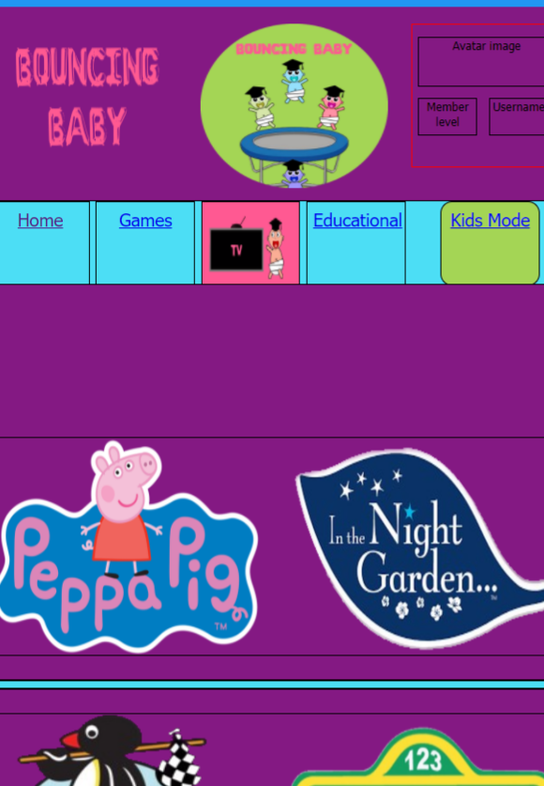Viewing the original concept of the application (Figure3) the colours chosen do not seem to be adequate and need to be adjusted feedback on this design was provided by a parent “The colour purple makes it difficult to read the black text although I do like the idea of using images with text alongside them.” Looking more into this feedback, multiple studies such as “children reading pictures: Interpreting visual texts” by (Arizpe, 2003) provides solid evidence such as on-page;29. Picture books put children front and centre as they are learning through pictures with an adult observing them. This is a great way for children to learn at an early age, as they are enjoying themselves whilst learning.

Figure Original concept of Bouncing Baby website

# The Second Design

After the previous feedback, the background colour was altered and so was the navigational menu (Figure 4). During building the application it was noticed that the current colour tone was too bright, causing issues with focusing and reading straining the eyes. After looking more into this, it was found (Boyco, 2017) stated that “blue light also reaches deeper into the eye, causing damage to the retina.”

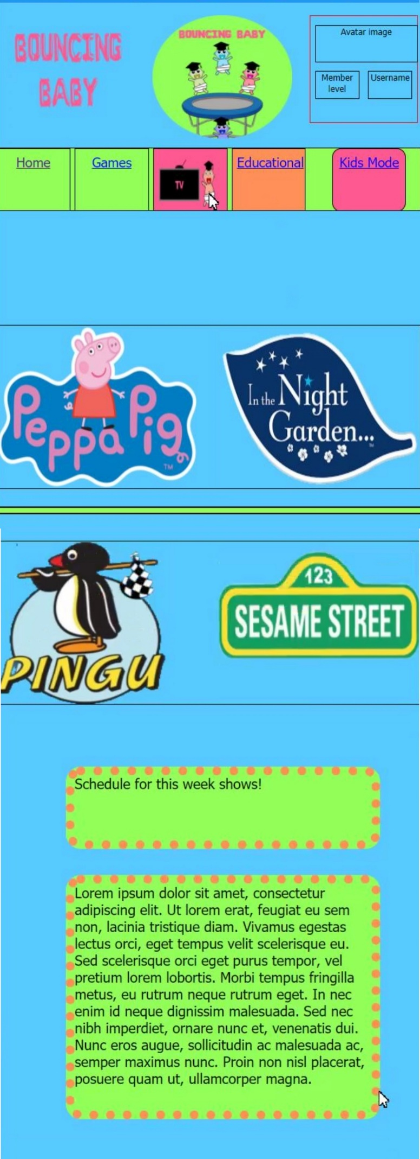

Figure Second Design

# Final Design

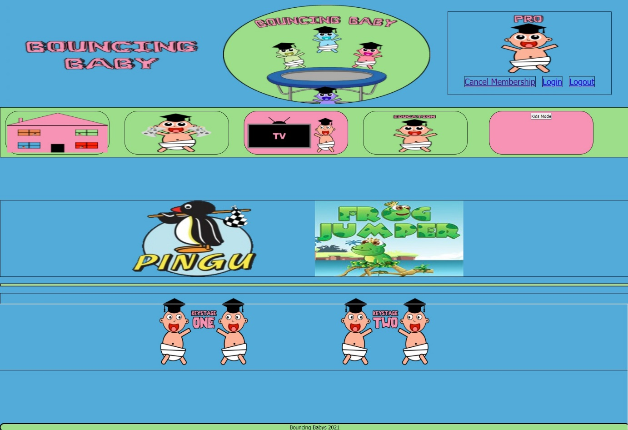Once discovering this the colour tone was altered once again, (Figure5) to a smoother tone that was a lot easier on the eyes, the colours chosen still maintained the same as the colour blue (Simpson, 2018)“Suggests calmness, loyalty, peace, serenity, and security, therefore creates a sense of comfort.” As well as keeping the visual literacy for the navigational menu a decision was made to implement audio alongside this as studies also show there are three learning styles (Anderson, 2019) “visual, auditory, and kinesthetic. Visual learners must see it to absorb it; auditory learners need to hear it to master it; and kinesthetic or tactile learners need to move or experience it to understand it.”

Figure Final Design Kids Homepage

### Why audio was used in the final design

As stated above there are three types of learning styles, but this could also aid impairment granting ease of access to other users who may struggle with reading such as dyslexic children, (Western Goverment University, 2020) ”Auditory learners process information best by hearing it, so using repetition and repeating spoken information can help them comprehend best.”

# Adult design

The adult colour harmony used is complementary, but instead of being a high contrast, it is a very smooth design as shown in (Appendix B to J). Instead of using images and audio on the navigation bar, the text is used to display the information. This is because adults may find the features too repetitive and may annoy them, so they may lose interest in the web application Additional information was also added to the adult layout such as contact and about us and an advert for upgrading the account. The reason why these features are not present on the child website is that it would not be ethical to have these features available to children to maintain online safety. (Zhao, 2010)” Children may be particularly vulnerable to online advertising”

## Layout differences

Comparing the adult design to the kid’s design, the content is more compact as adults will not get lost with too much content displayed. This is supported by (Appendix B to AZ) as shown on the heatmap, the user has been able to view the information and navigate with ease.

## Conclusion

In conclusion, the website had some pretty strong features but there are still adjustments and changes that need to be made, for example, decreasing the amount of use of audio on the website as it can be a little bit too repetitive and children may lose focus and begin to play with the audio.

# Bibliography

Anderson, D. (2019, April 11th). *Is Your Child an Auditory Learner? 5 Strategies to Boost Learning*. Retrieved from ReadSmartLearning: https://readsmartlearning.com/is-your-child-an-auditory-learner-5-strategies-to-boost-learning/

Arizpe, E. a. (2003). Children reading pictures: Interpreting visual texts. In E. A. Arizpe, *Children reading pictures: Interpreting visual texts* (pp. 26-31). London: Taylor and Francis. doi:9780415275767

Boyco, A. (2017, September 20th). *Best Colors for a Computer Screen to Use on Eyes*. Retrieved from Image: https://image.ca/best-colors-for-computer-screen-on-eyes/

Canva. (2021). *Colour theory and the colour wheel*. Retrieved from Canva: https://www.canva.com/colors/color-wheel/

Coral, N. (2020, February 2nd). *Understanding Analogous Colors*. Retrieved from The Spruce: https://www.thespruce.com/understanding-analogus-colors-1973820

Lundekvam, S., & Green, P. (2019). *How is colour harmony perceived by observers with a colour vision deficiency?* Gjøvik, Norway: Society for Imaging Science and Technology. doi:https://doi.org/10.2352/ISSN.2470-1173.2019.14.COLOR-091

POTASHNIK, B. (2016, August 26th). *Once again about colour theory*. Retrieved from creatorship: https://creativshik.com/eshhe-raz-o-teorii-cveta/

SHALLBETTER, J. L. (2013). *COLOR WHEEL*. Retrieved April 15th, 2021, from COLOR WORQX: https://worqx.com/color/color_wheel.htm

Simpson, R. (2018, May 26th). *Five Ways Colour Can Affect Children in a Learning Environment*. Retrieved from LSN Education: http://www.lsneducation.org.uk/five-ways-colour-can-affect-children-learning-environment/

Tiger Color. (2015). *Basic techniques for combining colours*. Retrieved April 15th, 2021, from tiger colour: https://www.tigercolor.com/color-lab/color-theory/color-harmonies.htm

Western Government University. (2020, August 10th). *Auditory learning style explained.* Retrieved from Western Government University: https://www.wgu.edu/blog/auditory-learning-style2008.html

Zhao, X. C. (2010). *Online advertising practices on popular children's websites, Journal of Children and Media.* Taylor Francis online. doi:10.1080/17482791003629610

# Appendix/Appendices

1. Below is a set of tests which were conducted on the Bouncing Baby website.

|  |  |  |  |  |
| --- | --- | --- | --- | --- |
| Test Number | What you tested | What should have happened | What did happen | Was it a success? (Success/Failed) |
| 1 | Home Page Link on the Home Page. | The home page link should not link anywhere when on the home page. | The home page link is a dead link on the home page itself. | Success |
| 2 | Home Page Link Sound Effect Home Page. | The home page sound effect should not play when on the home page. | The home page sound effect does not play when on the home page. | Success |
| 3 | Games Page Link on the Home Page. | The games page link should link to the games page from the home page. | The games page link takes the user to the games page. | Success |
| 4 | Games Page Link Sound Effect Home Page. | The games page link sound effect should play when hovered over. | The games page link plays the respected sound effect when hovered over. | Success |
| 5 | TV Shows Link on the Home Page. | The TV Shows link should link to the TV Shows page from the home page. | The TV Shows page link takes the user to the games page. | Success |
| 6 | TV Shows Link Sound Effect Home Page. | The TV Shows link sound effect should play when hovered over. | The TV Shows link plays the respected sound effect when hovered over. | Success |
| 7 | Education Link on the Home Page. | The Education link should link to the TV Shows page from the home page. | The Education link takes the user to the games page. | Success |
| 8 | Education Link Sound Effect Home Page. | The education link sound effect should play when hovered over. | The education link sound effect plays when hovered over. | Success |
| 9 | Kids Mode Link on the Home Page. | The kid’s mode link should change to the adult version of the website. | The kid’s mode link changes the website to the adult version. | Success |
| 10 | Kids Mode Link Warning. | The kid’s mode warning should display at the top of the page once the kid’s mode link is clicked. | The kid’s mode warning displays at the top of the screen once the kid’s mode link is pressed. | Success |
| 11 | Kids Mode Link Warning Confirm. | The kid’s mode warning confirm link should take the user to the adult version of the website. | The kid’s mode warning confirm link successfully takes the user to the adult version of the website. | Success |
| 12 | Kids Mode Link Warning Cancel. | The kid’s mode warning cancel link should take the user to the adult version of the website. | The kid’s mode warning cancel link breaks and still takes the user to the adult version of the website. | Failed |
| 13 | Kids Mode Sound Effect Home Page. | The kid’s mode link sound effect should play when hovered over. | The kid’s mode link sound effect should play when hovered over. | Success |
| 14 | Navigation Buttons. | The navigation buttons should change to orange when hovered over. | The navigation buttons change to an orange colour when hovered over. | Success |
| 15 | Pingu Link on the Home Page. | The Pingu link on the home page should take the user to the respective video. | The Pingu link successfully takes the user to the respected video. | Success |
| 16 | Frog Jumper Link on the Home Page. | The frog jumper link on the home page should take the user to the respected game. | The frog jumper link successfully takes the user to the respected video. | Success |
| 17 | KS1 Link on the Home Page. | The ks1 link on the home page should take the user to the ks1 page. | The ks1 link takes the user to the ks1 page. | Success |
| 17 | KS1 Link Sound Effect on the Home Page. | The ks1 link sound effect should play when hovering over the ks1 link. | The ks1 page link plays the respected sound effect when hovered over. | Success |
| 19 | KS2 Link on the Home Page. | The ks2 link on the home page should take the user to the ks2 page. | The ks2 link takes the user to the ks2 page. | Success |
| 20 | KS2 Link Sound Effect on the Home Page. | The ks2 link sound effect should play when hovering over the ks2 link. | The ks2 page link plays the respected sound effect when hovered over. | Success |
| 21 | Home Page Link on the Games Page. | The home page link should link to the home page on the website. | The home page link on the games page successfully links to the home page. | Success |
| 22 | Home Page Sound Effect on the Games Page. | The home page sound effect should play when hovering over the home page link. | The home page links successfully play the sound effect when hovered over. | Success |
| 23 | The Games Page Link on the Games Page. | The games page link should not link anywhere when on the games page. | The games page link is a dead link when on the games page itself. | Success |
| 24 | The Games Page Sound Effect on the Games Page. | The games link sound effect on the games page should not work while on the games page. | The games page sound effect does not play when hovering over the games page link. | Success |
| 25 | The TV Shows Page Link is on the Games Page. | The TV shows page link should take the user to the TV shows page when clicked. | The TV shows page link takes the user to the TV shows page from the games page. | Success |
| 26 | The TV Shows Page Sound Effect on the Games Page. | The TV shows link sound effects on the games page should play its respected sound when hovered over. | The TV Shows page sound effect plays when hovering over the games page link. | Success |
| 27 | The Education Page Link is on the Games Page. | The education page link should take the user to the education page when clicked | The education page link takes the user to the education page from the games page. | Success |
| 28 | The Education Page Sound Effect on the Games Page. | The education link sound effect on the games page should play its respective sound when hovered over. | The education page sound effect plays when hovering over the games page link. | Success |
| 29 | Kids Mode Link on the Games Page. | The kid’s mode link should change to the adult version of the website. | The kid’s mode link changes the website to the adult version. | Success |
| 30 | Kids Mode Sound Effect on the Games Page. | The kid’s mode link sound effect should play when hovered over. | The kid’s mode link sound effect should play when hovered over. | Success |
| 31 | The European Cities game is on the Games Page. | The European Cities game on the games page should play when clicked. | The European Cities game opens on a new tab when clicked. | Success |
| 32 | The Candy Crunch game is on the Games Page. (Free Version) | The Candy Crunch game on the free version of the games page should play when clicked. | The Candy Crunch game on the free version of the games page doesn’t work when clicked due to not having the pro version of the website. | Success |
| 33 | The Whack the Moles game on the Games Page. (Free Version) | The Whack the Moles game on the free version of the games page should play when clicked. | The Whack the Moles game on the free version of the games page doesn’t work when clicked due to not having the pro version of the website. | Success |
| 34 | The Frog Jumper Game on the Games Page. | The Frog Jumper game on the games page should play when clicked. | The Frog Jumper game on the games page opens onto a new tab when clicked. | Success |
| 35 | The Cupid Bubble Game on the Games Page. | The Cupid Bubble game on the games page should play when clicked. | The Cupid Bubble game on the games page opens onto a new tab when clicked. | Success |
| 36 | The Spite and Malice Extreme Game on the Games Page. | The Spite and Malice Extreme game on the games page should play when clicked. | The Spite and Malice Extreme game on the games page opens onto a new tab when clicked. | Success |
| 37 | Home Page Link on the TV Shows Page. | The home page link should link to the home page. | The home page link takes the user to the home page. | Success |
| 38 | Home Page Link Sound Effect on the TV Shows Page. | The home page sound effect should play when hovered over. | The home page sound effect does play when hovering over the home page link. | Success |
| 39 | Games Page Link on the TV Shows Page. | The games page link should link to the games page from the home page. | The games page link takes the user to the games page. | Success |
| 40 | Games Page Link Sound Effect TV Shows Page. | The games page link sound effect should play when hovered over. | The games page link plays the respected sound effect when hovered over. | Success |
| 41 | TV Shows Link on the TV Shows Page. | The TV Shows link should not link to the TV Shows page while on the TV Shows page. | The TV Shows page does not take the user to the TV Shows page. | Success |
| 42 | TV Shows Link Sound Effect TV Shows Page. | The TV Shows link sound effect should not play when hovered over. | The TV Shows link does not play while on the TV Shows page. | Success |
| 43 | Education Link on the TV Shows Page. | The Education link should link to the education Page. | The Education link takes the user to the Education page. | Success |
| 44 | Education Link Sound Effect on the TV Shows Page. | The education link sound effect should play when hovered over. | The education link sound effect plays when hovered over. | Success |
| 45 | Kids Mode Link on the TV Shows Page. | The kid’s mode link should change to the adult version of the website. | The kid’s mode link changes the website to the adult version. | Success |
| 46 | Kids Mode Sound Effect on the TV Shows Page. | The kid’s mode link sound effect should play when hovered over. | The kid’s mode link sound effect should play when hovered over. | Success |
| 47 | The Peppa Pig Link is on the TV Shows Page. | The Peppa Pig link should take the user to the respective video when clicked. | The Peppa Pig link takes the user to the respective video when clicked. | Success |
| 48 | The In the Night Garden Link is on the TV Shows Page. | The In the Night Garden link should take the user to the respective video when clicked. | The In the Night Garden link takes the user to the respected video when clicked. | Success |
| 49 | The Pingu Link on the TV Shows Page. (Free Version) | The Pingu link should not work on the free version of the website. | The Pingu link on the free version of the website does not work when clicked. | Success |
| 50 | The Sesame Street Link on the TV Shows Page. (Free Version) | The Sesame Street link should not work on the free version of the website. | The Sesame Street link on the free version of the website does not work when clicked. | Success |

1. 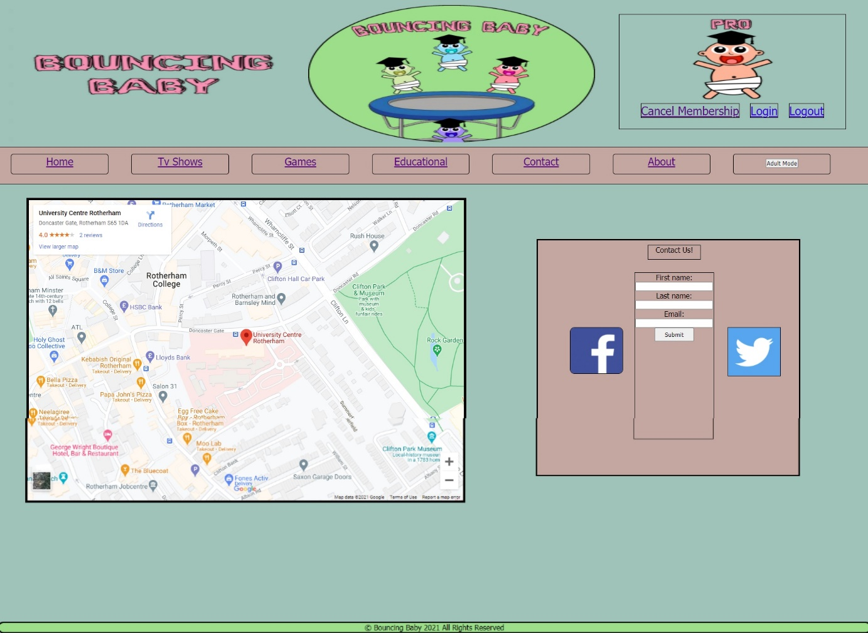Appendix Final designs of the website
2. 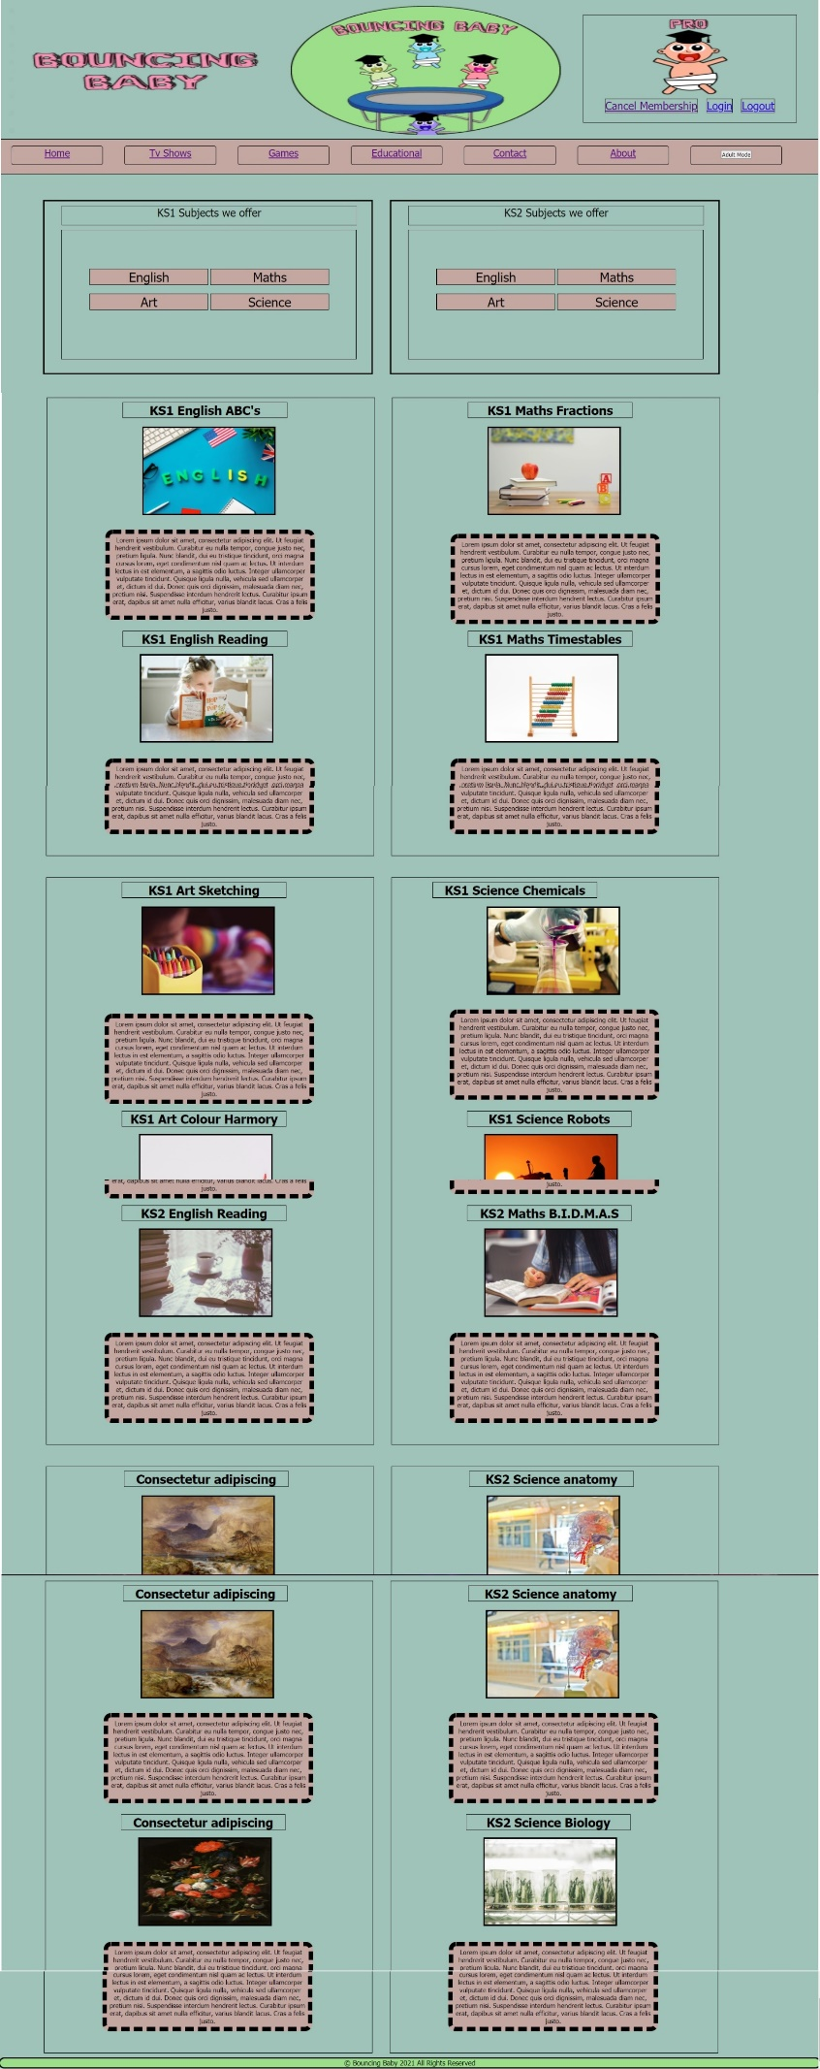
3. 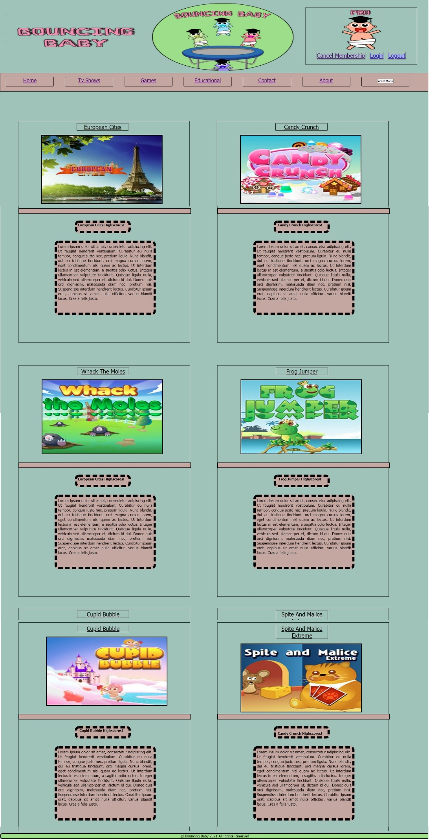
4. 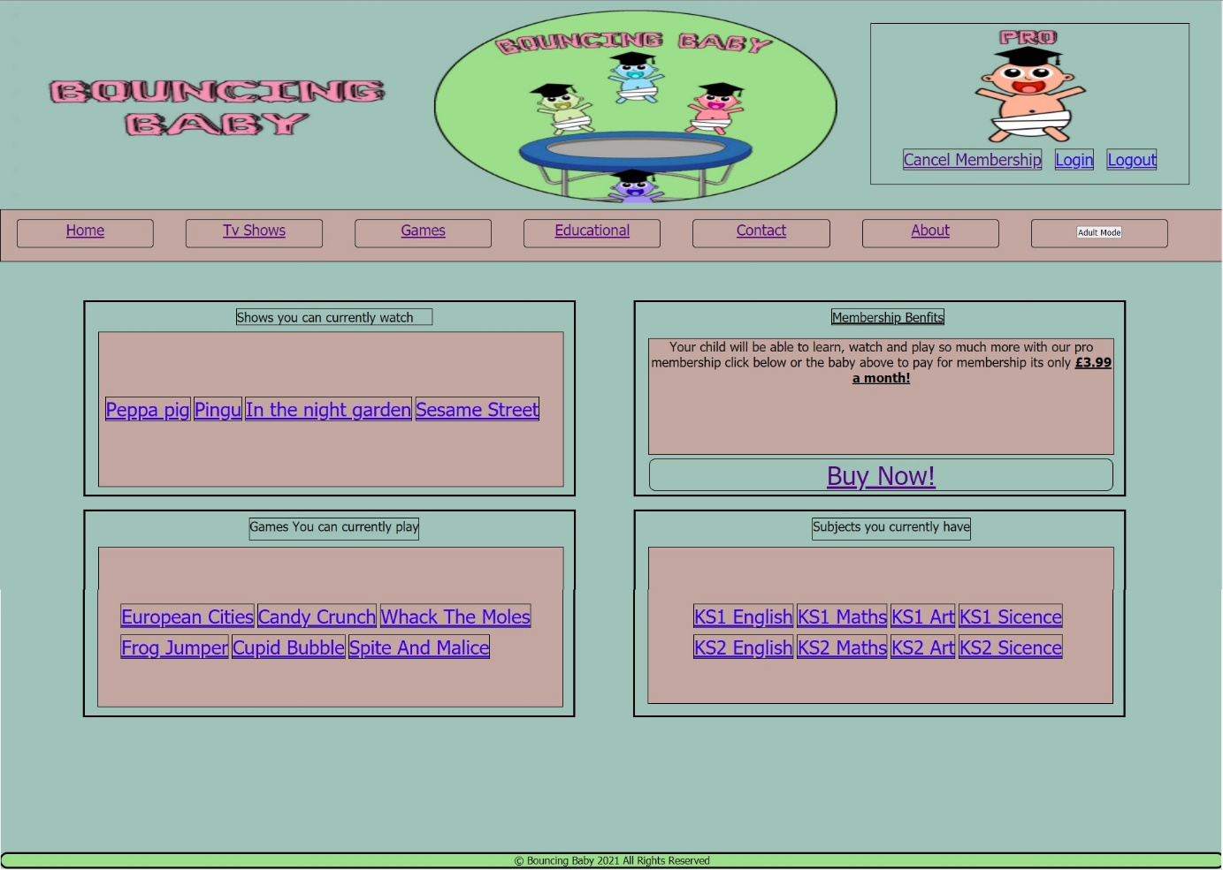
5. 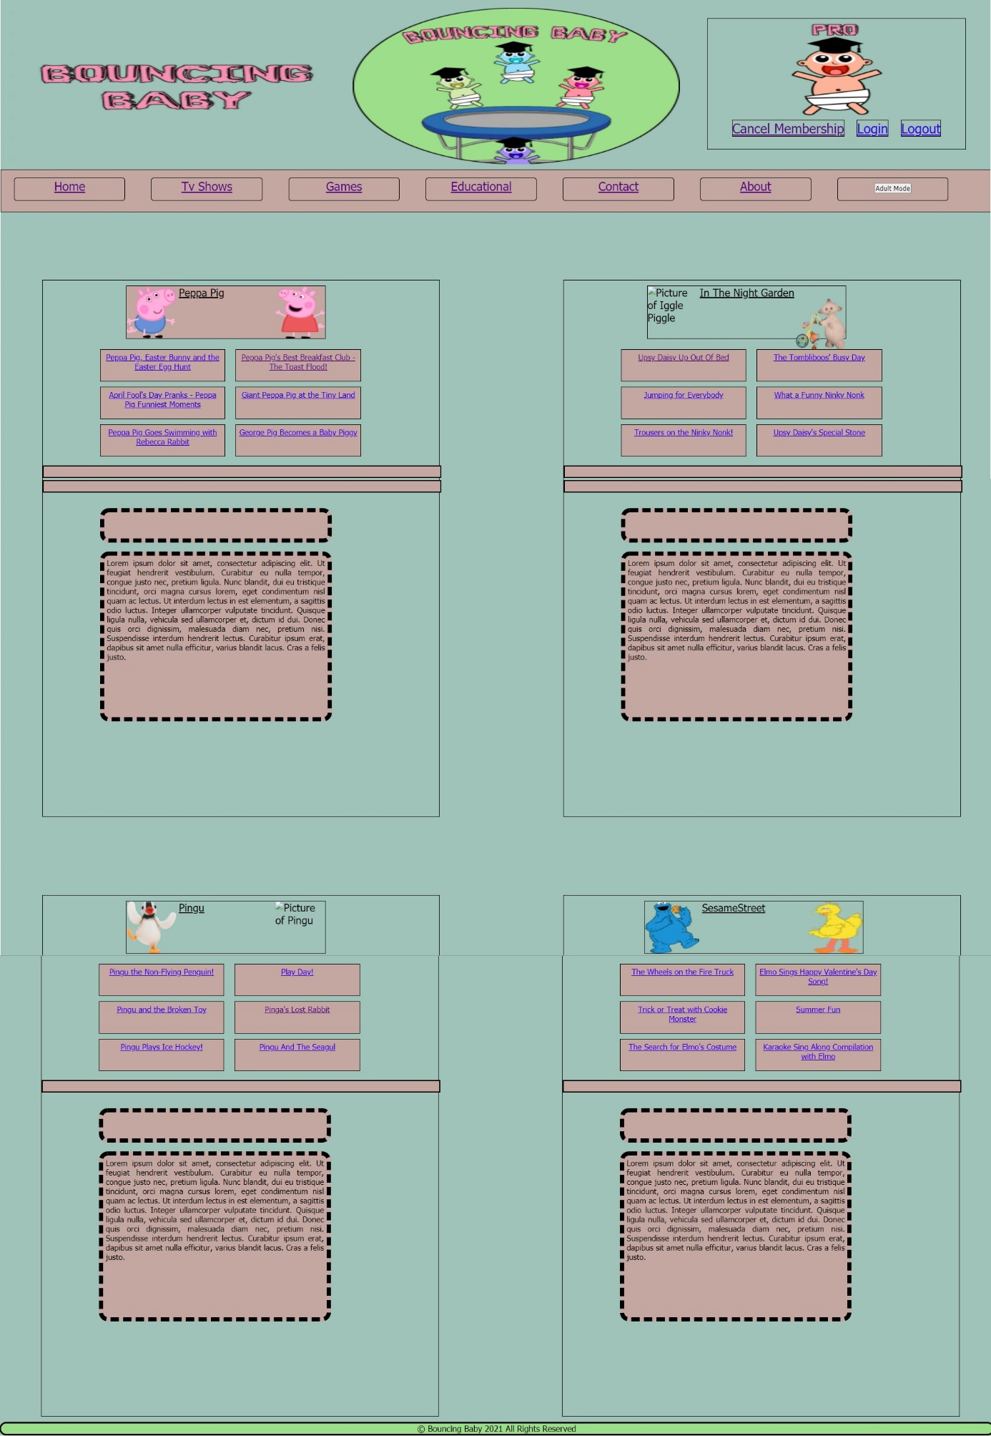
6. 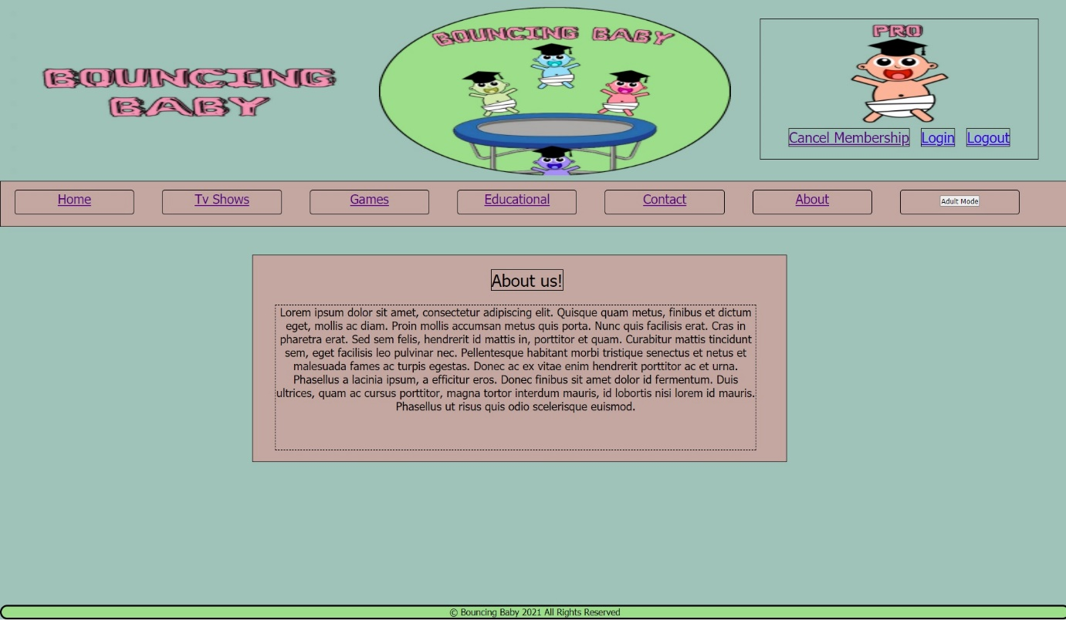
7. 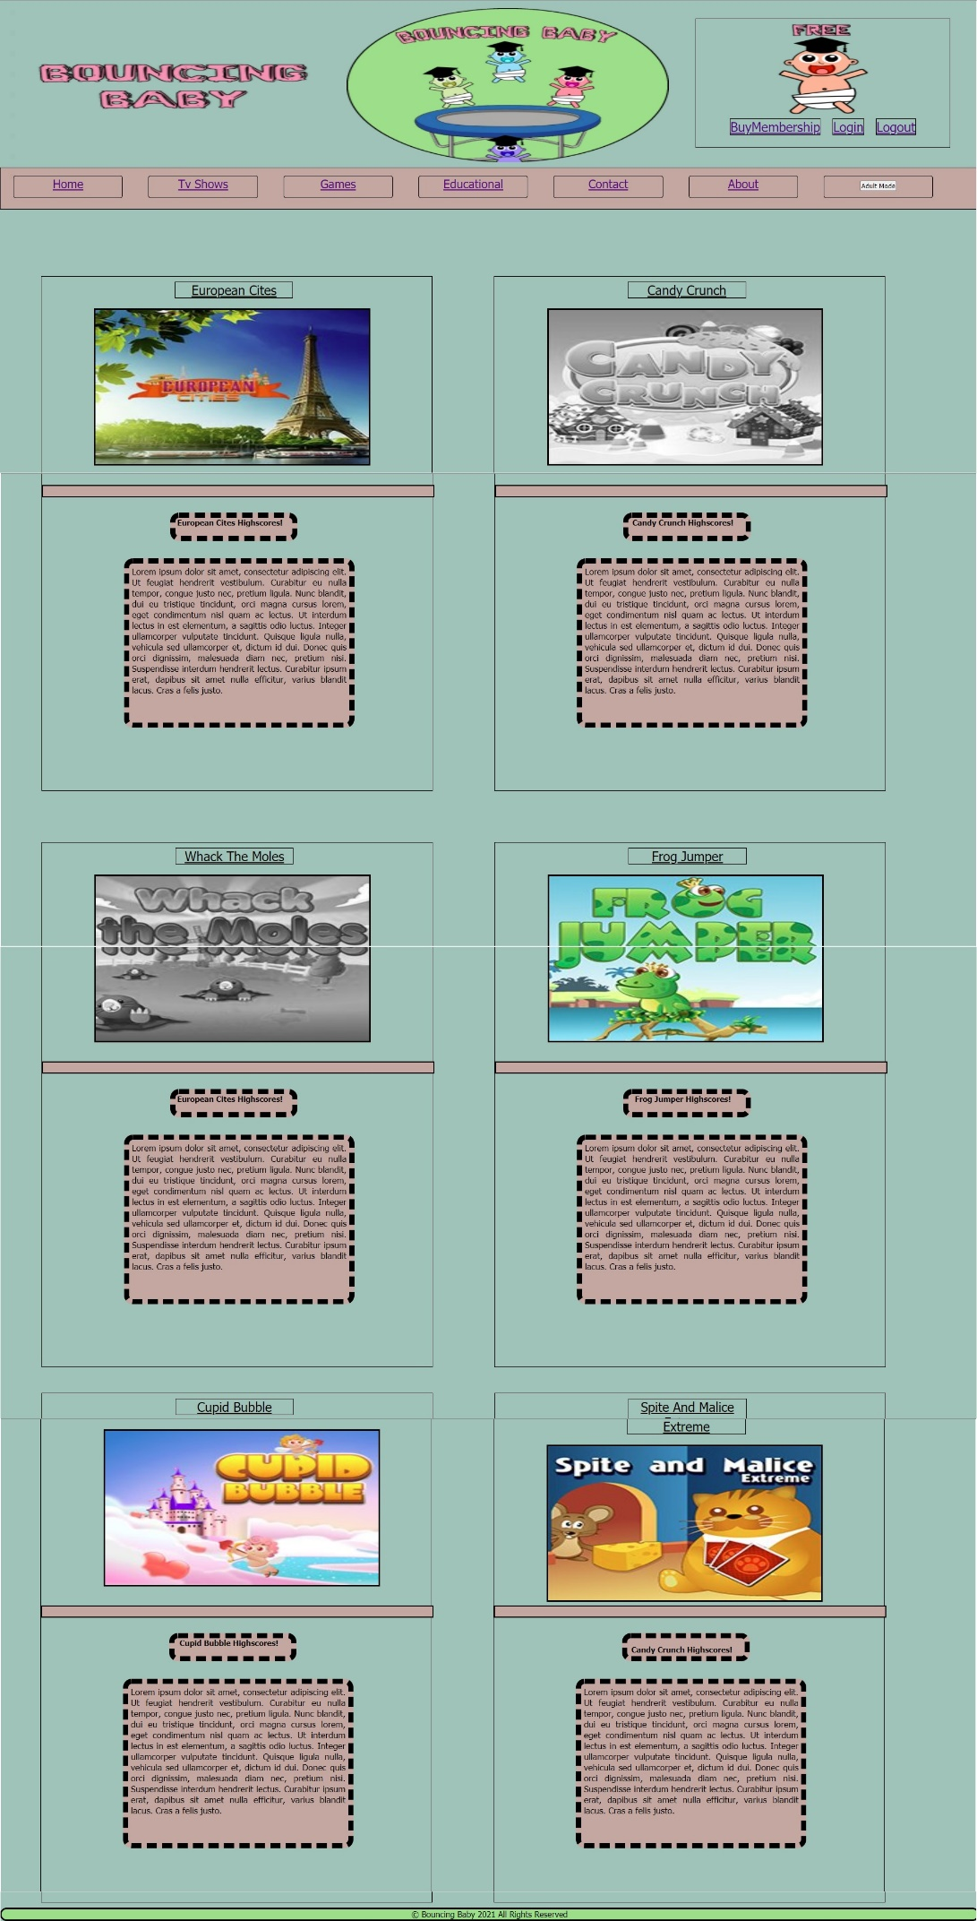
8. 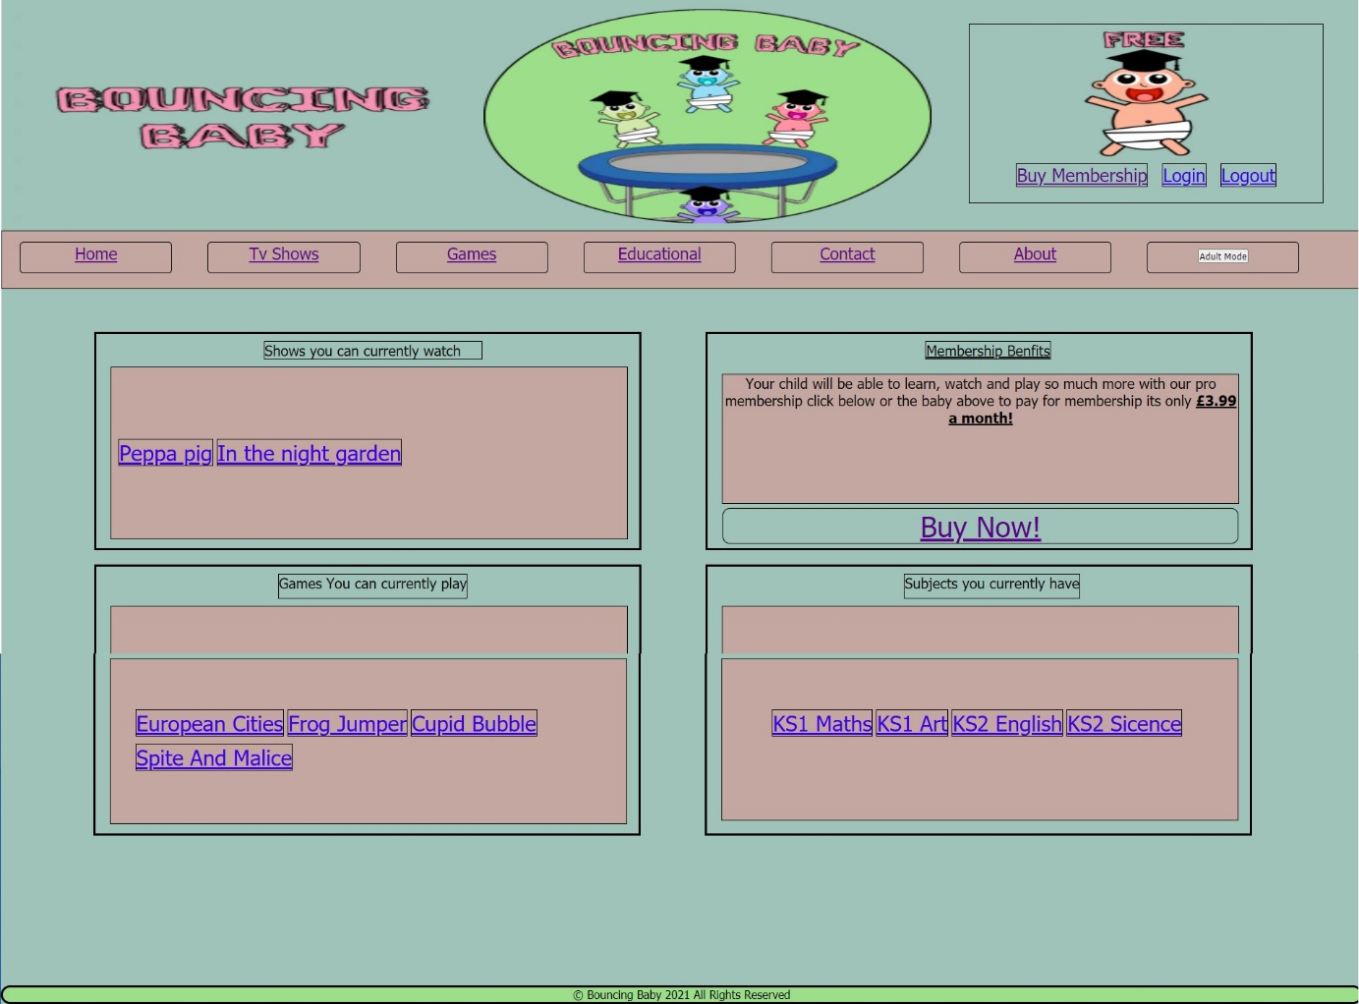
9. 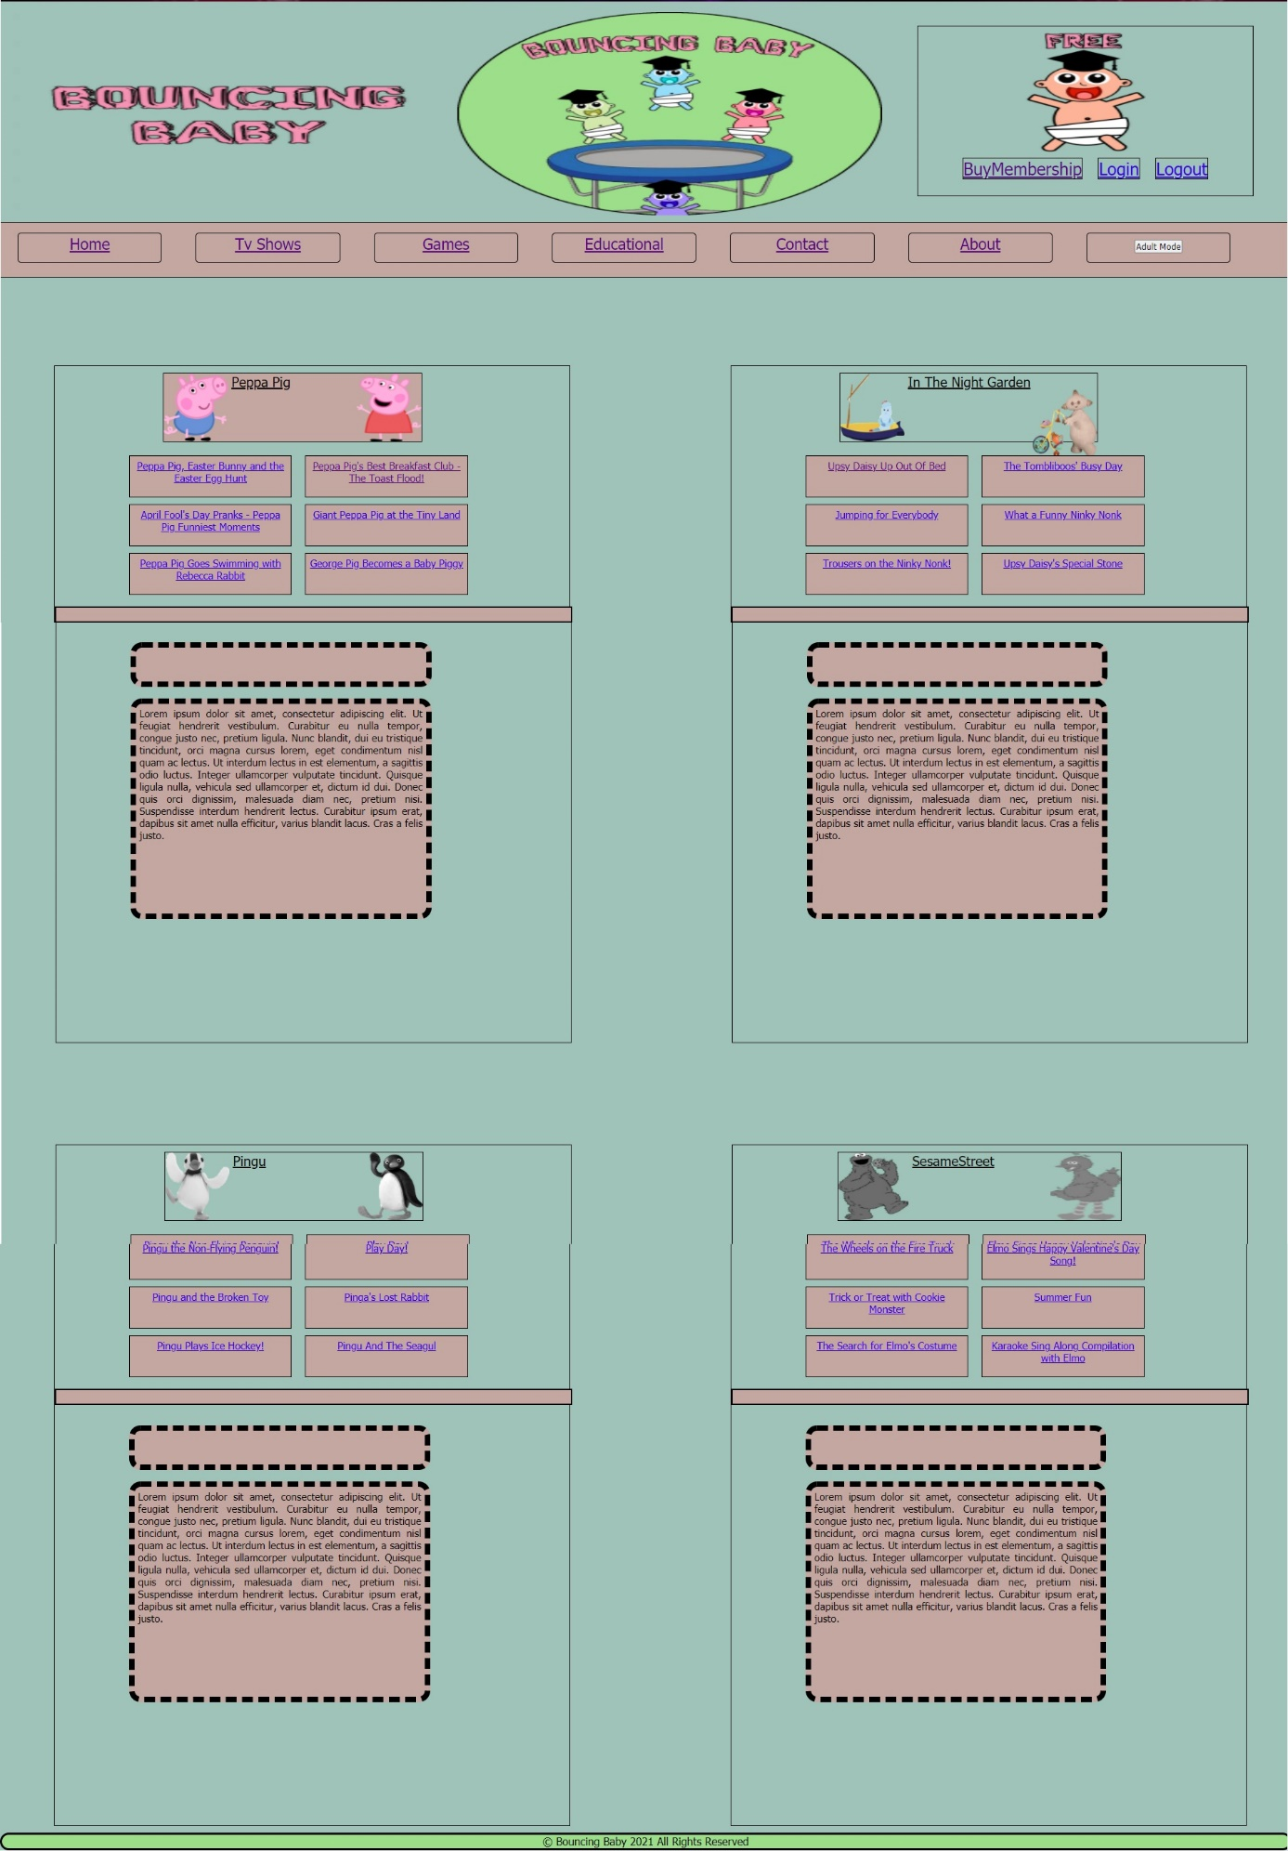

(K)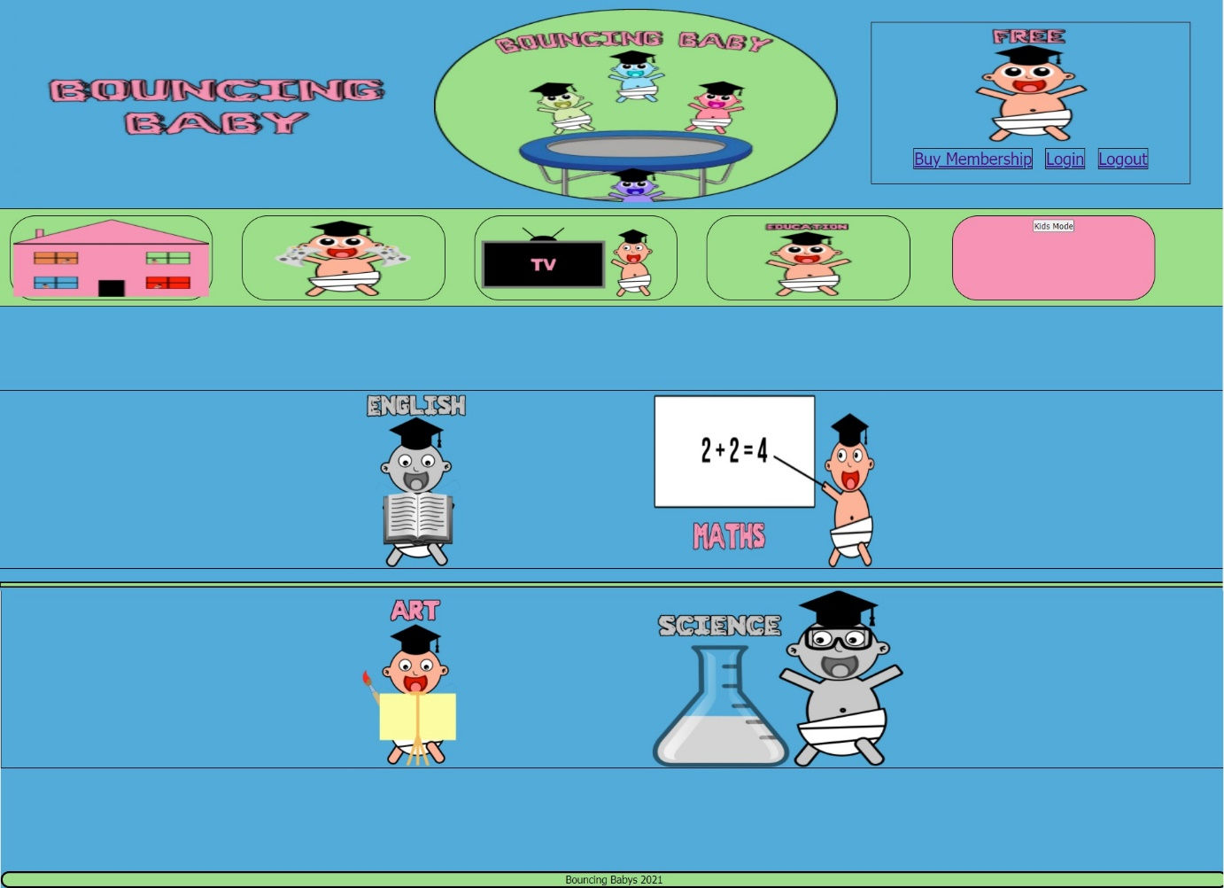

(L)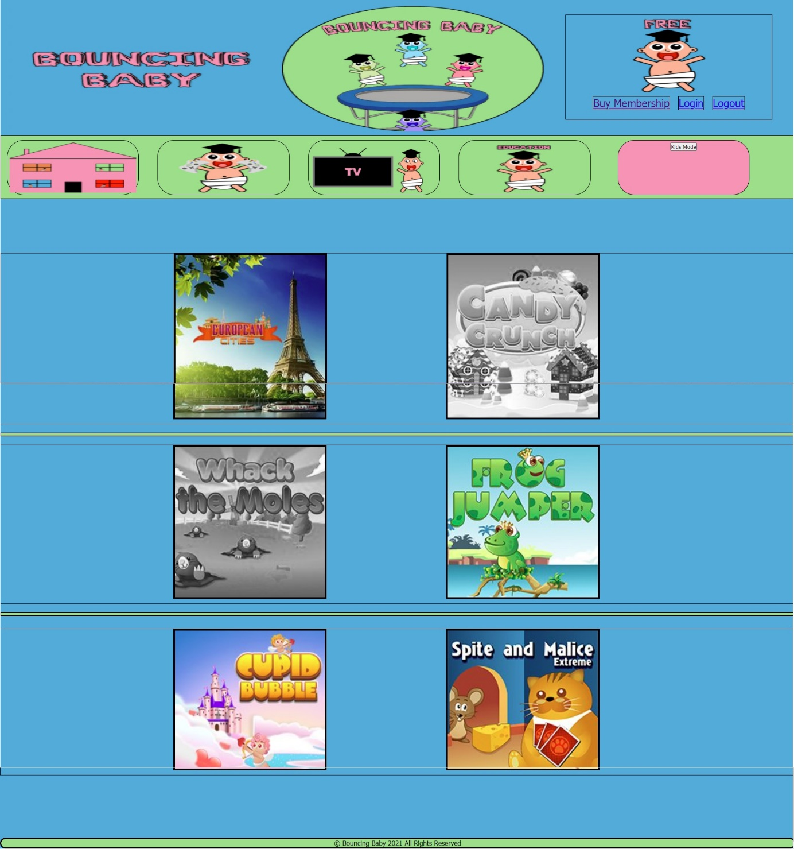

(M)

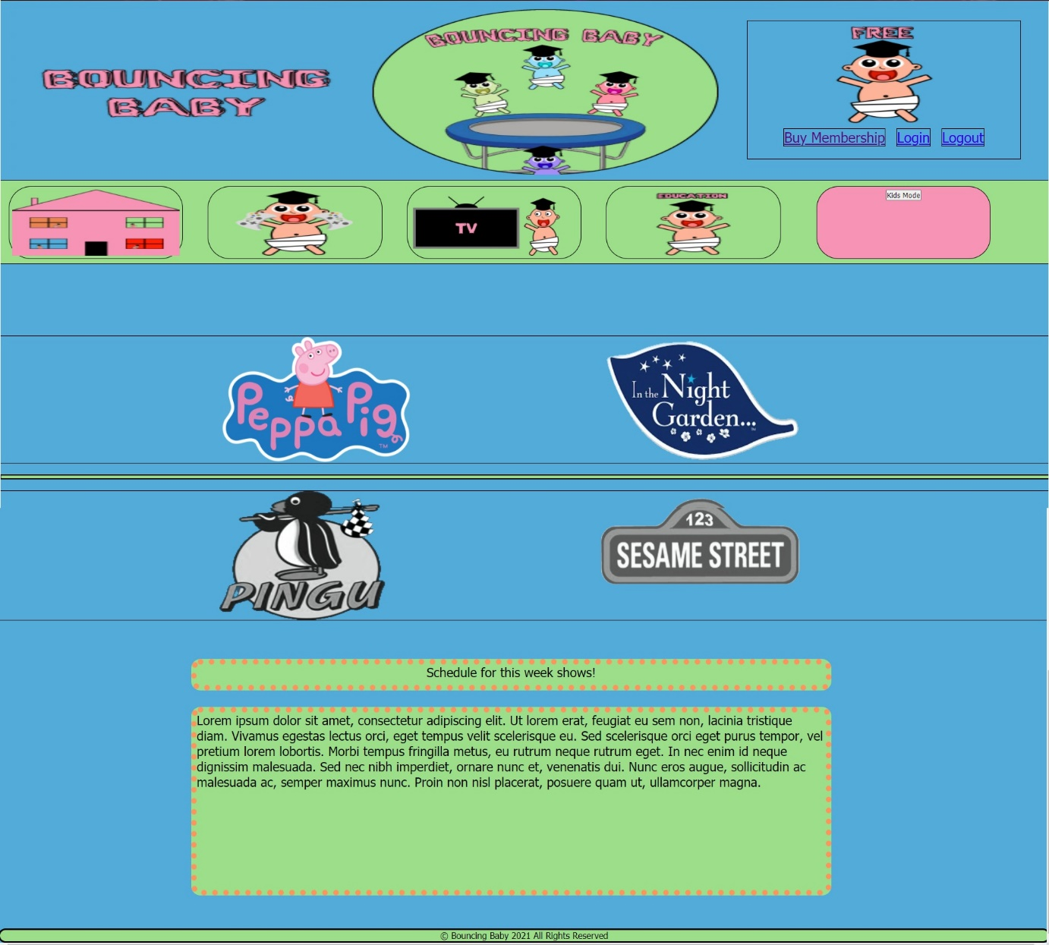

(N)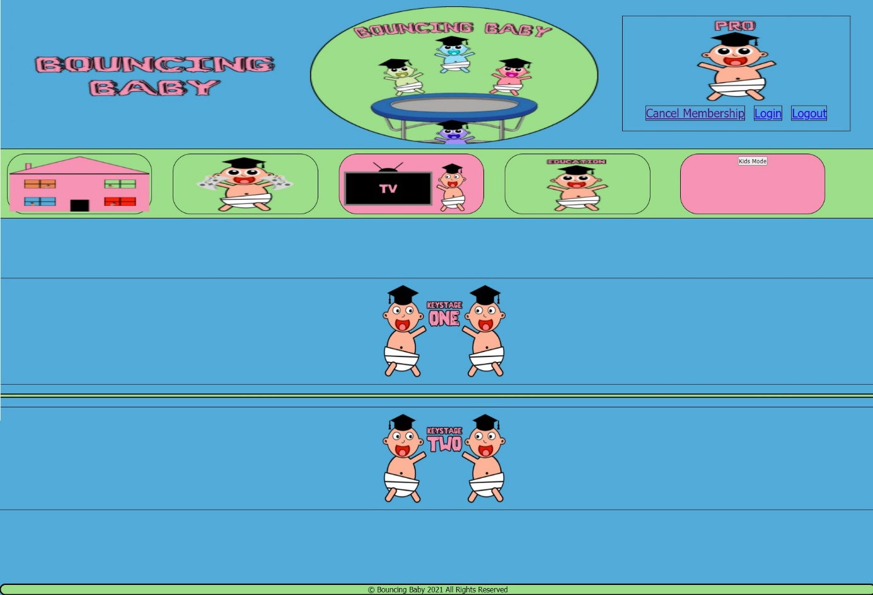

(O)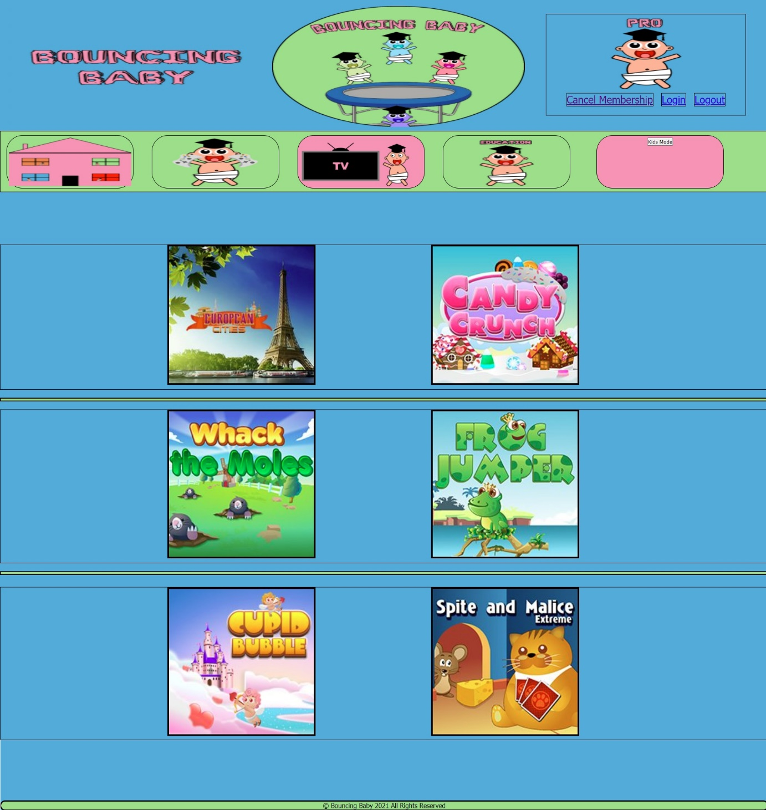

(P)

(Q)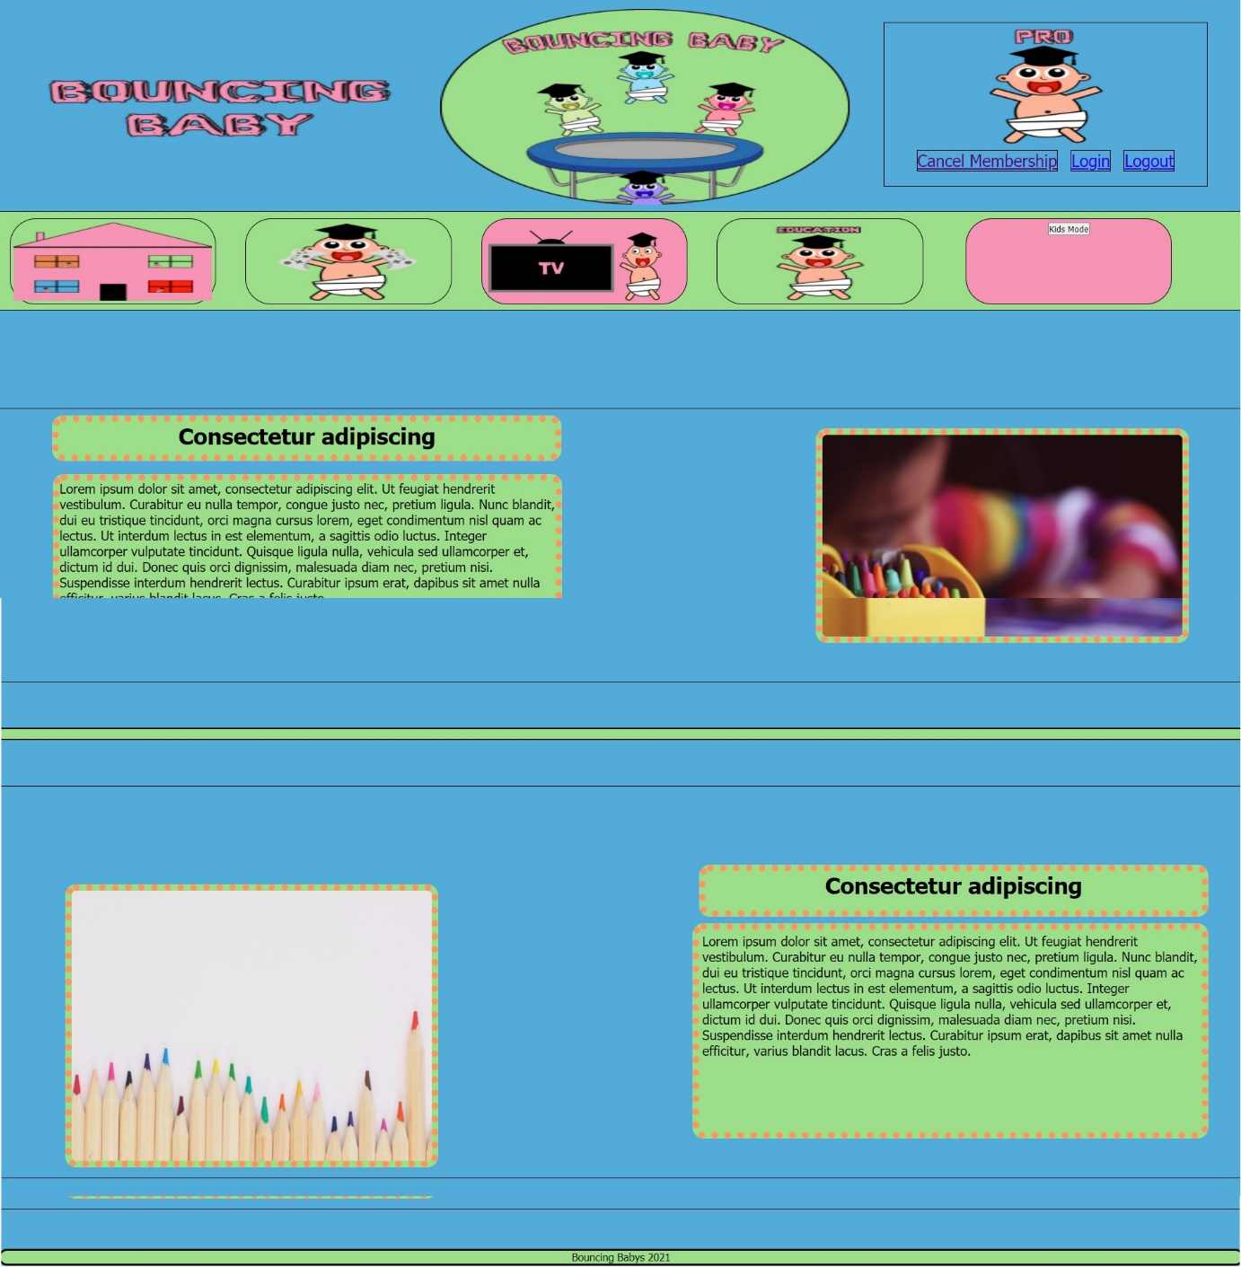

(R)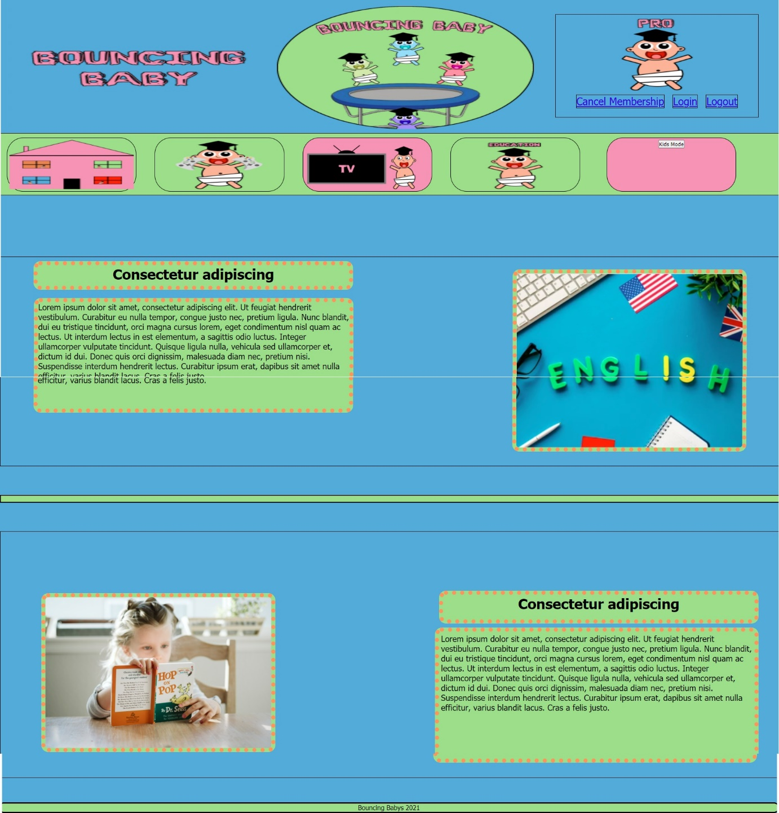

(S)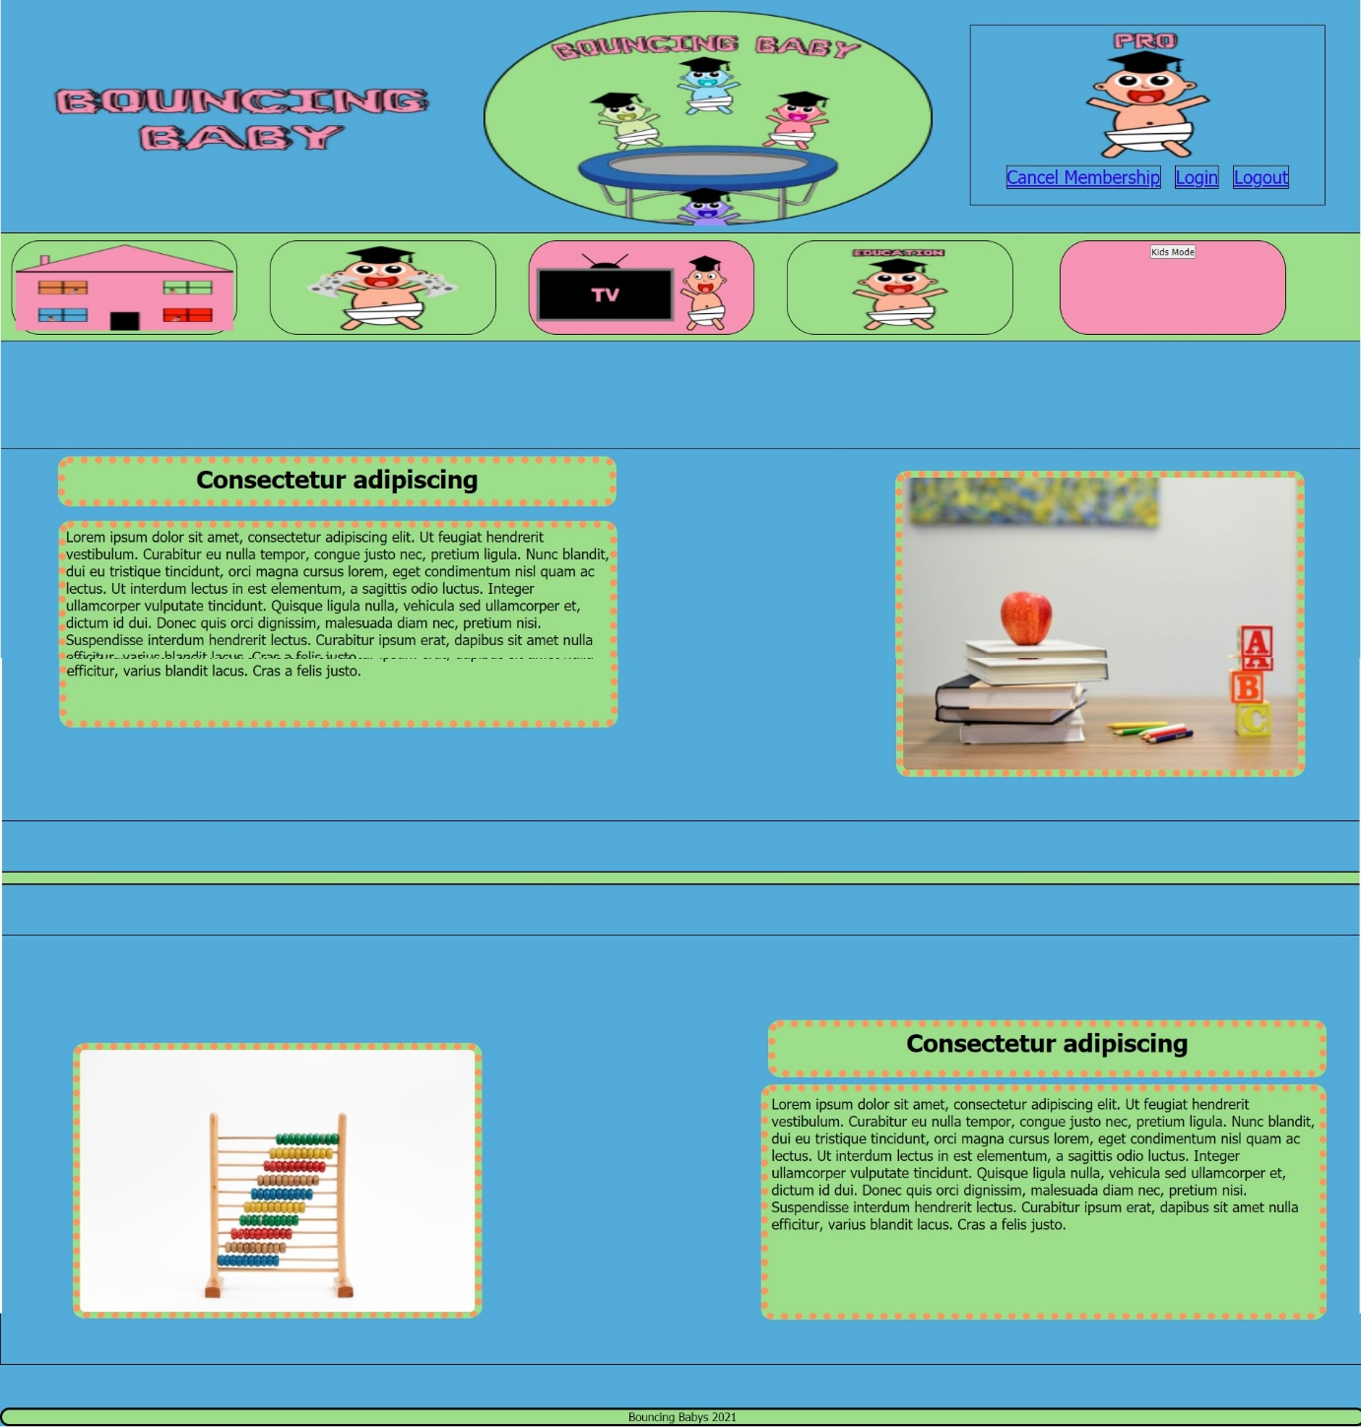

(T)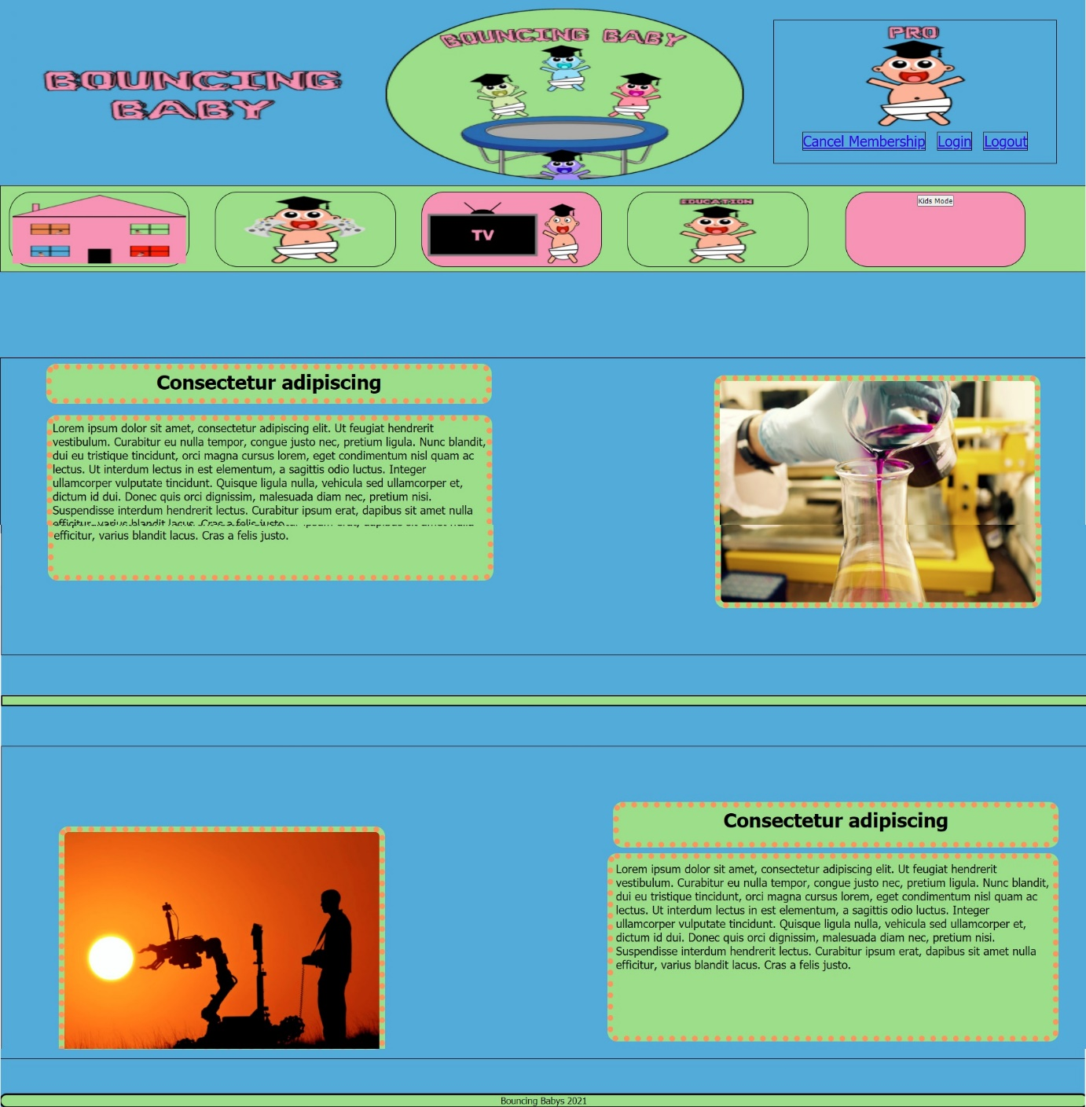

(U)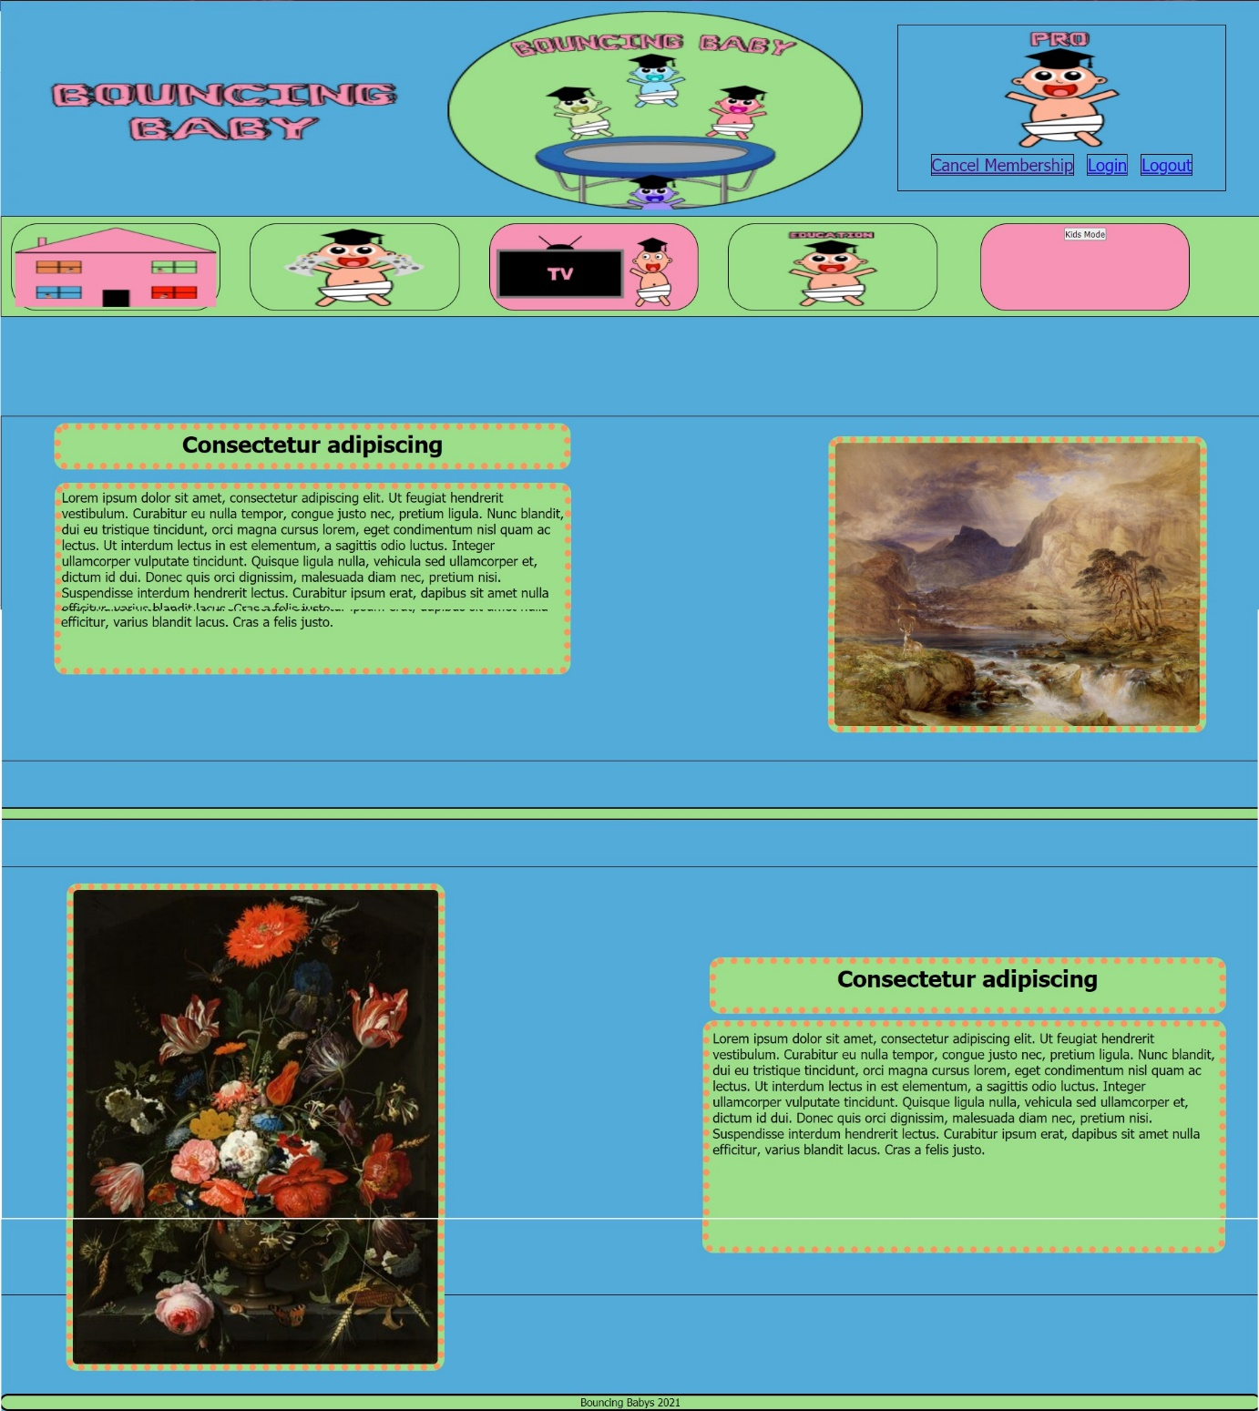

(V)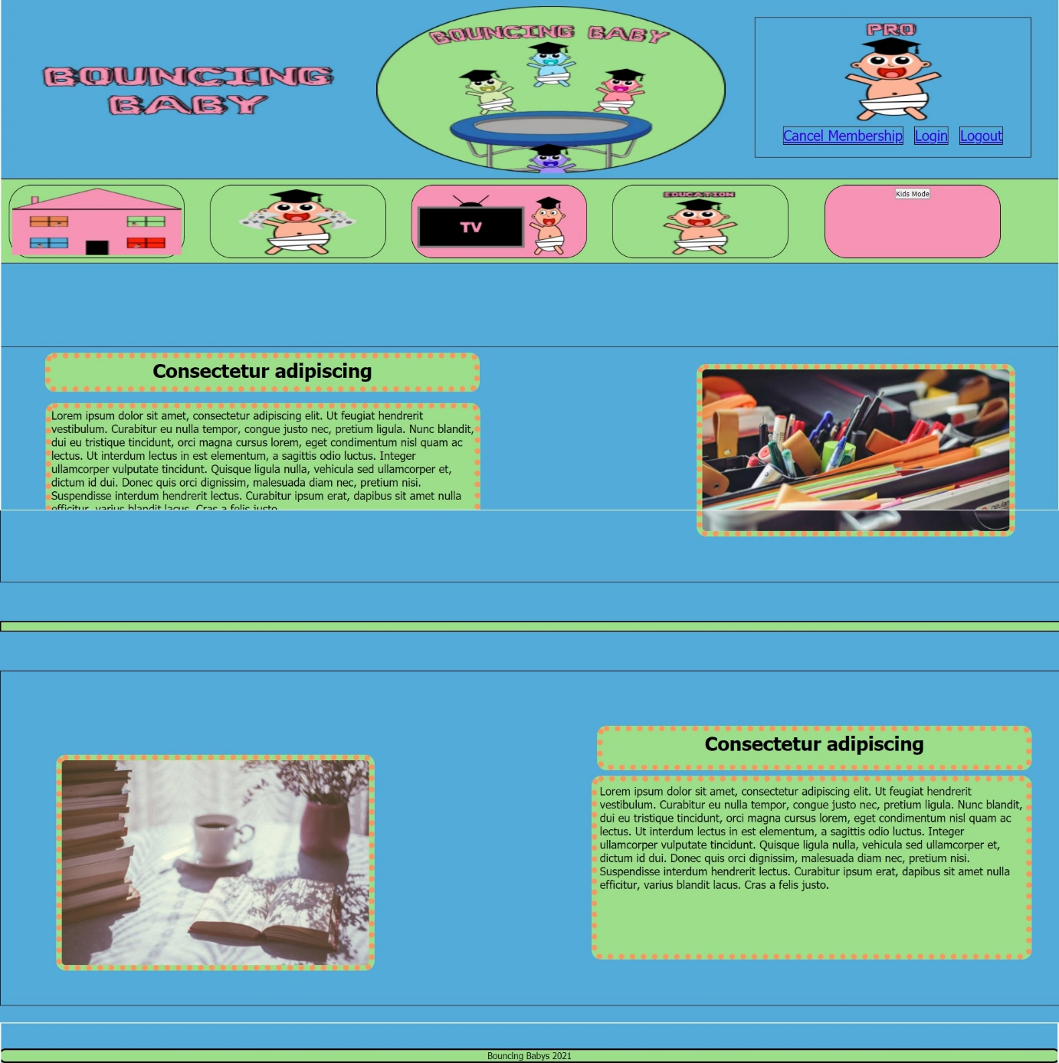

(W)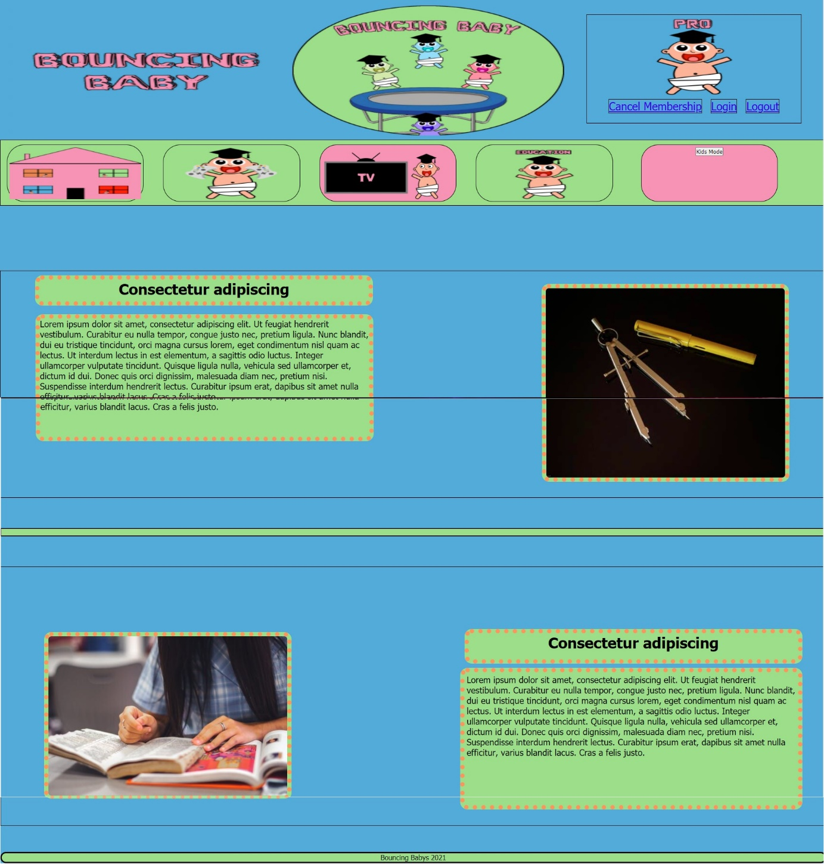

(X)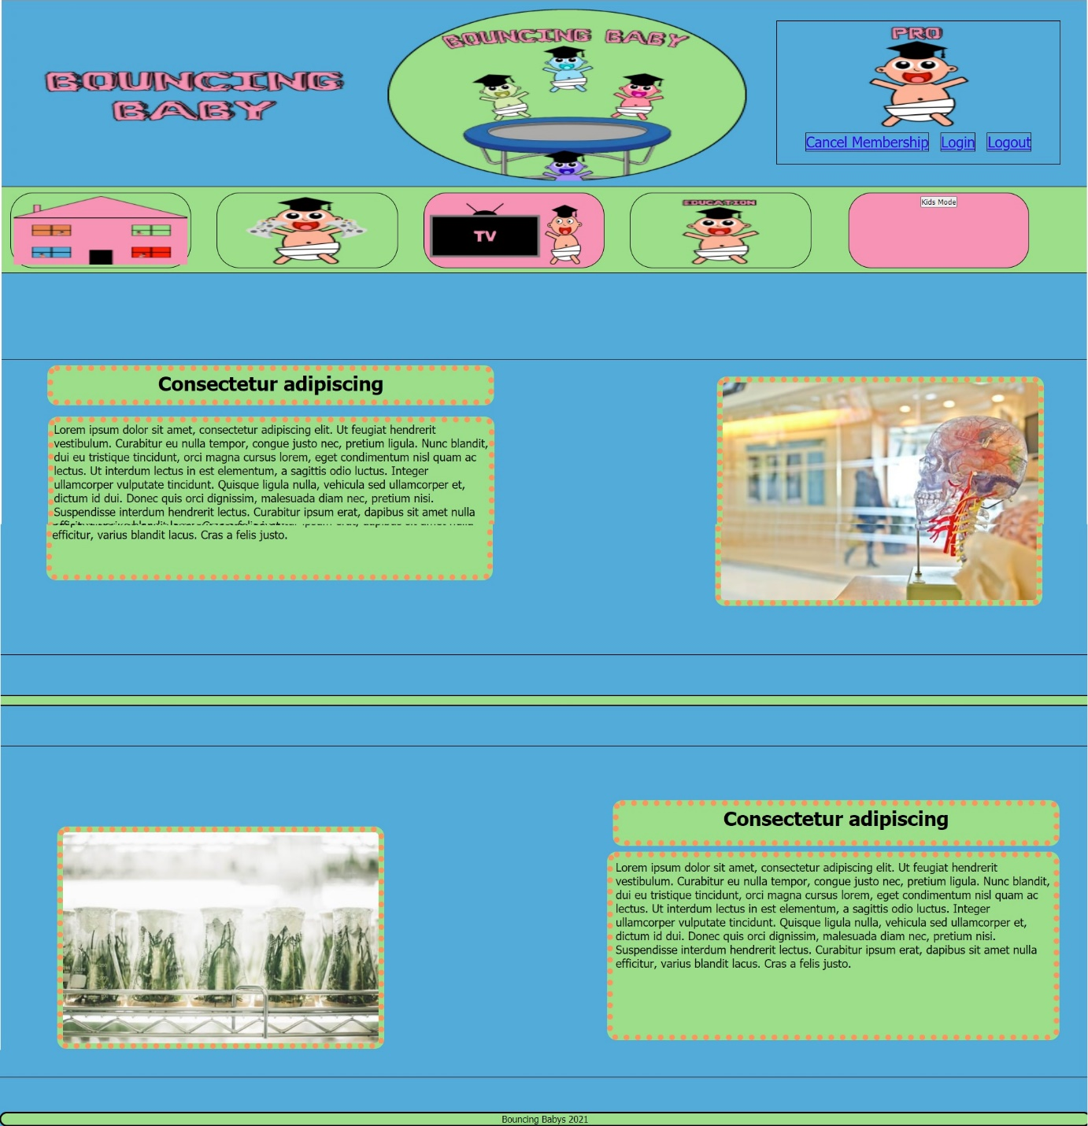(Y)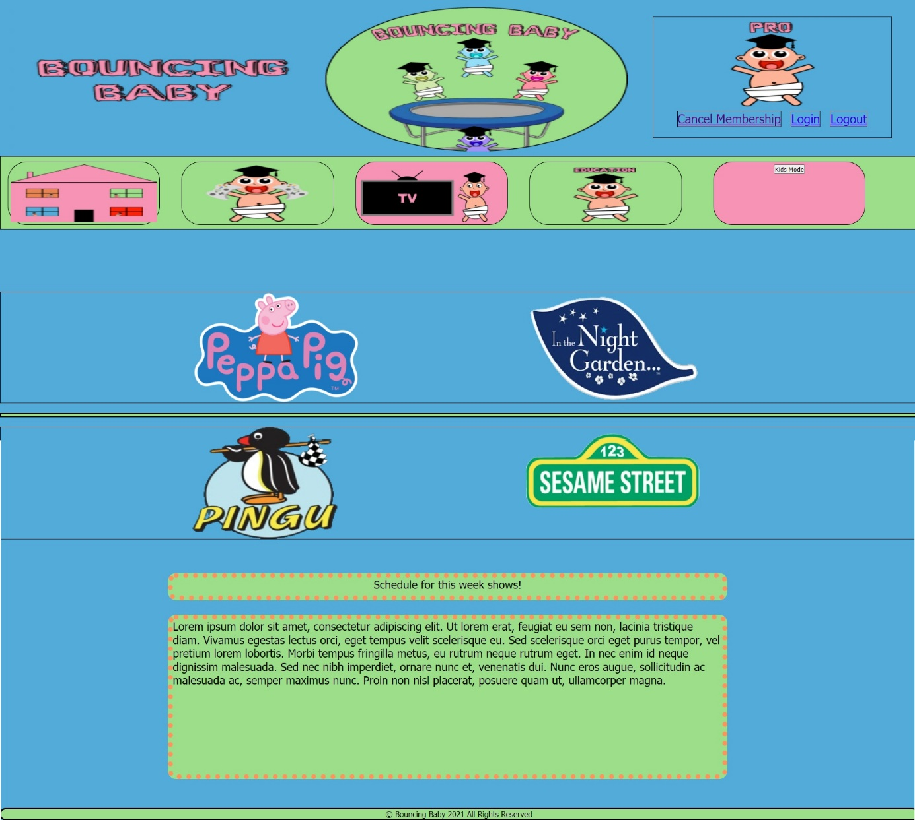

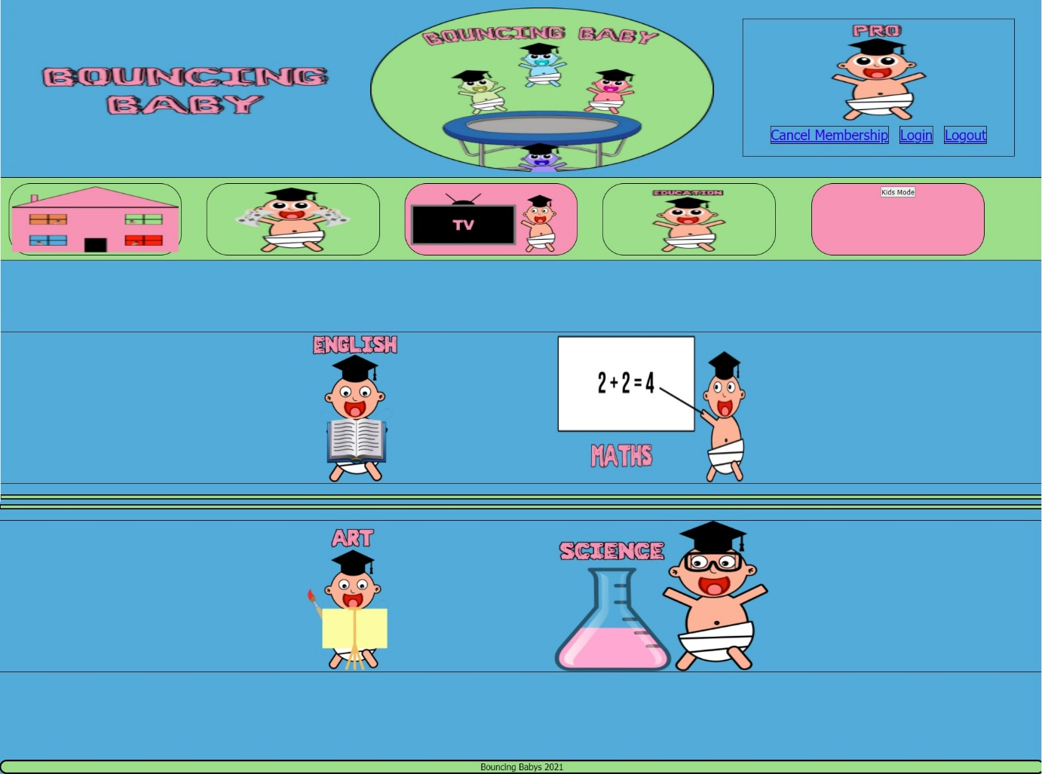(Z)

(AA)Appendix Heat maps of the entire website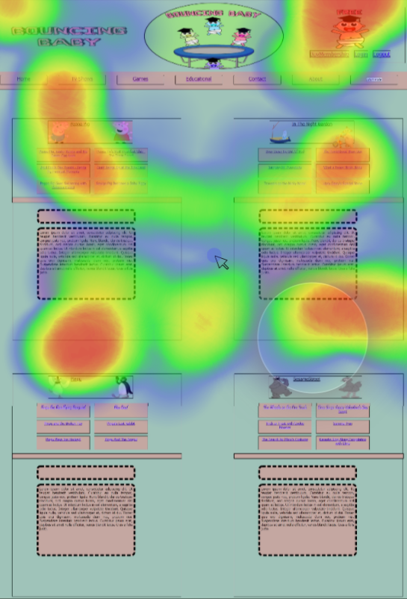

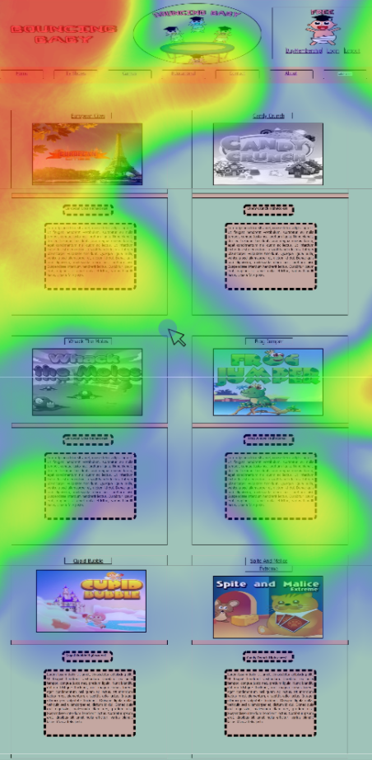(AB)

(AC)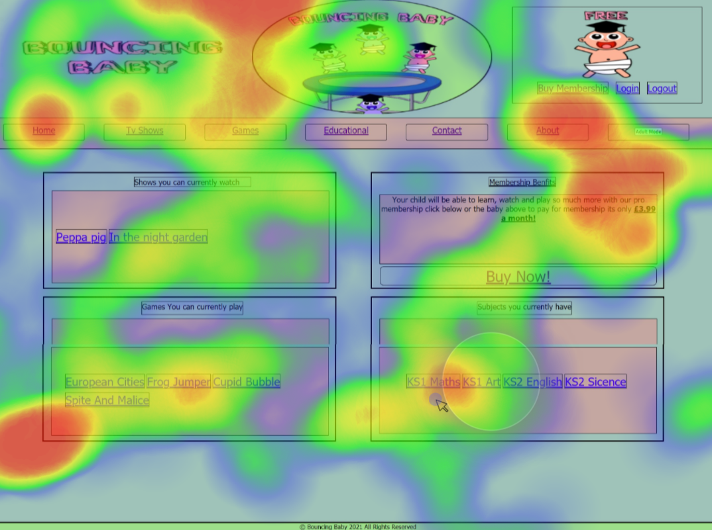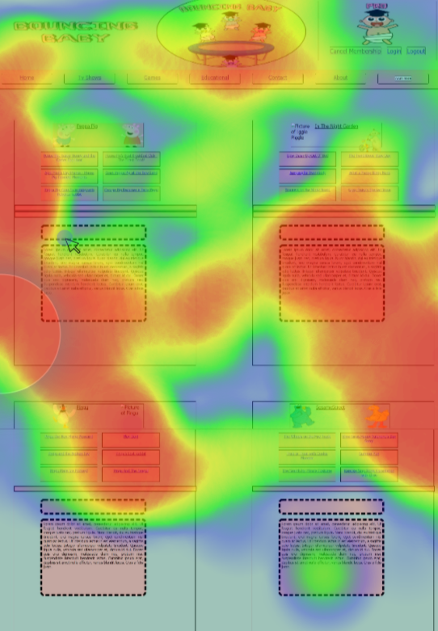(AD)

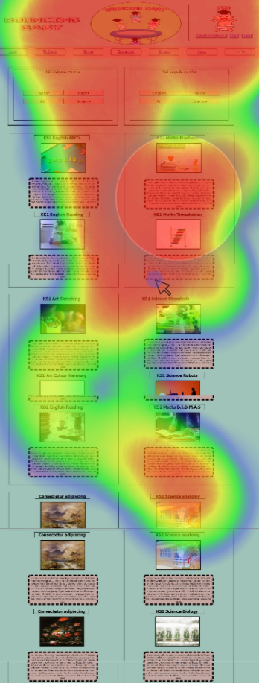(AE)

(AF)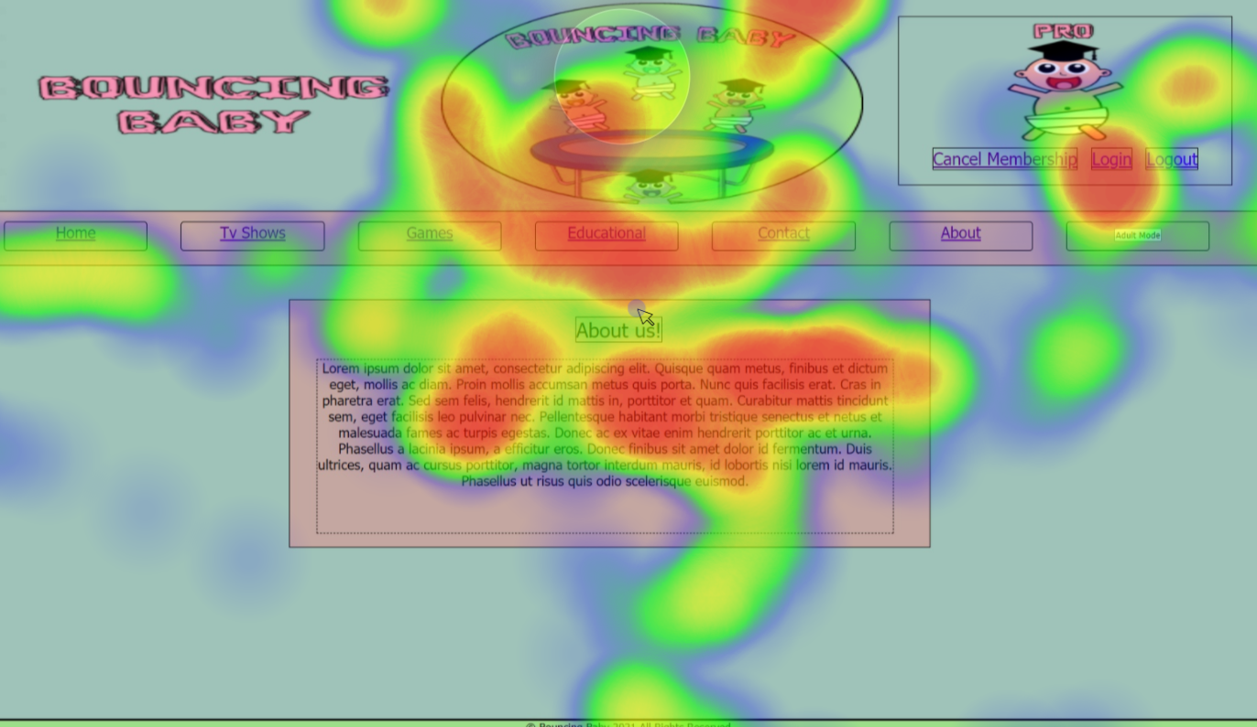

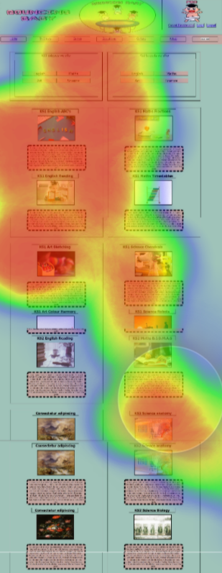(AG)

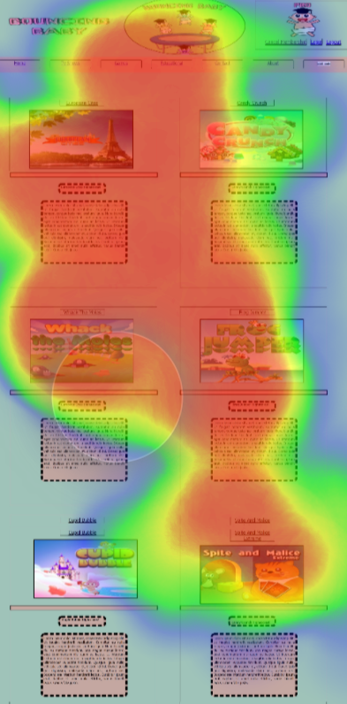(AH)

(AI)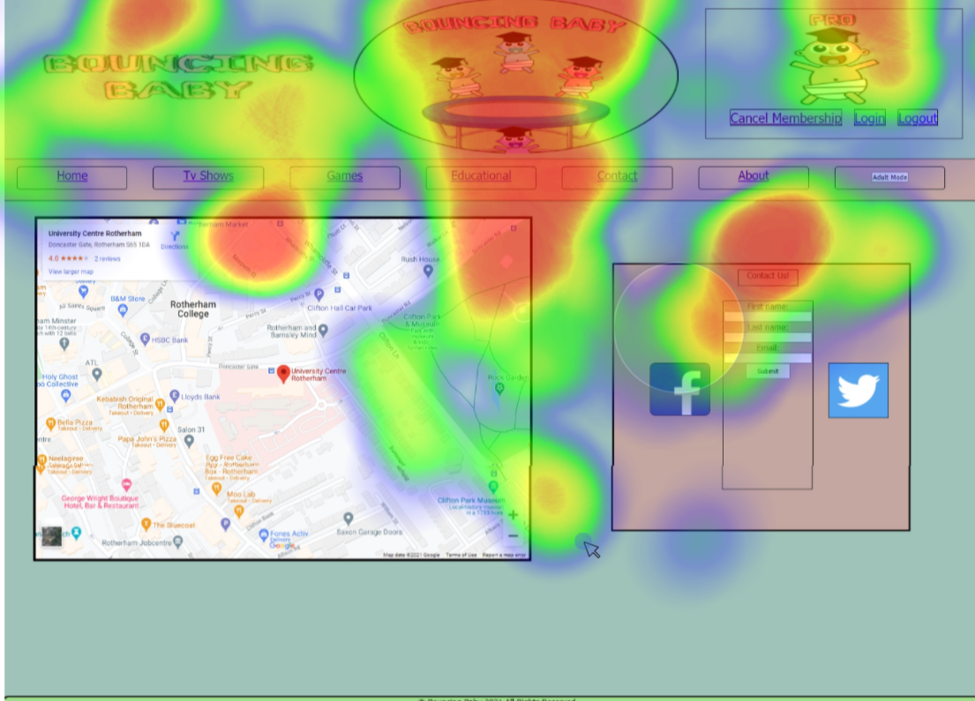

(AJ)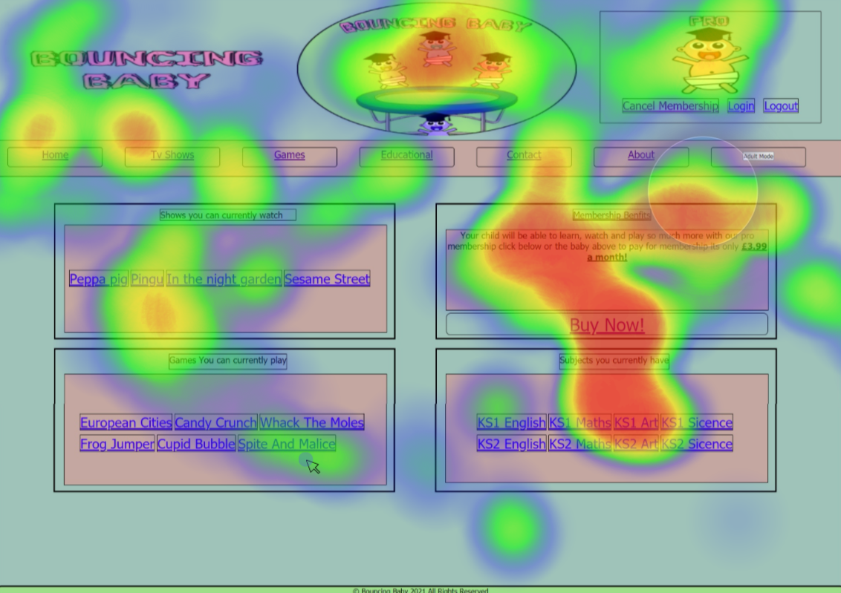

(AK)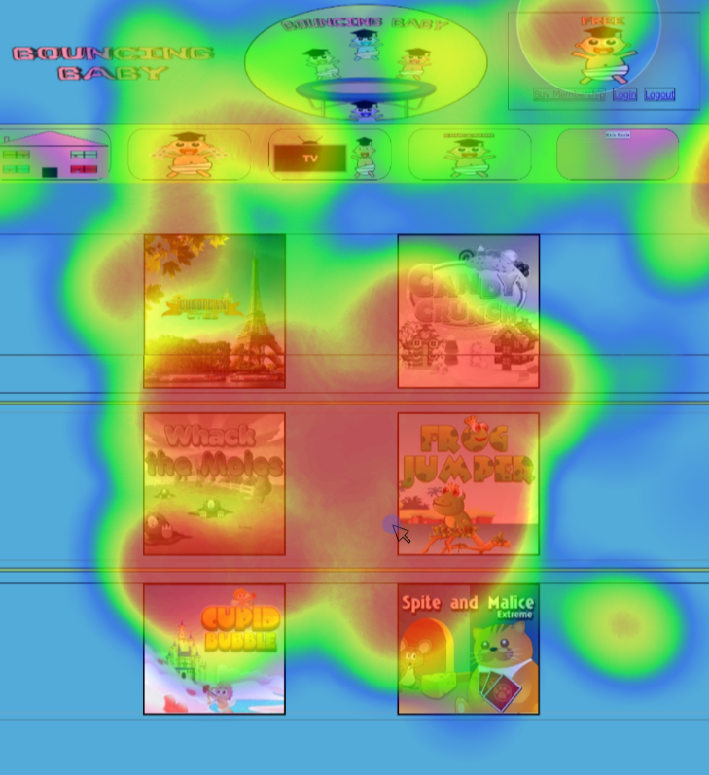

(AL)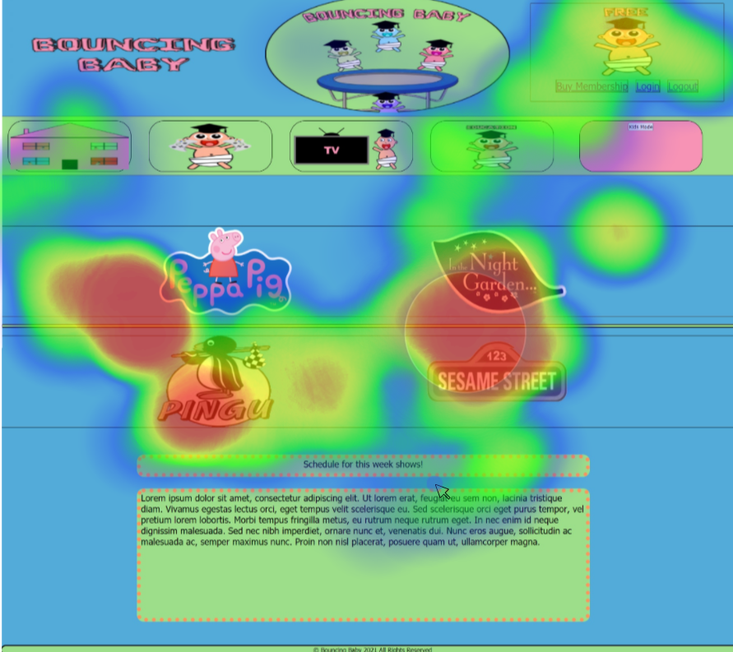(AM)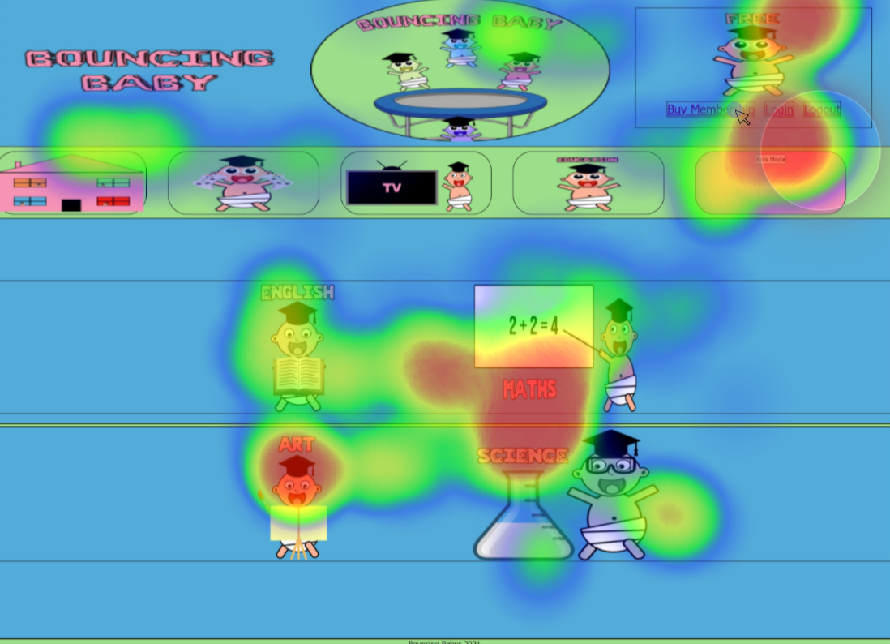

(AN)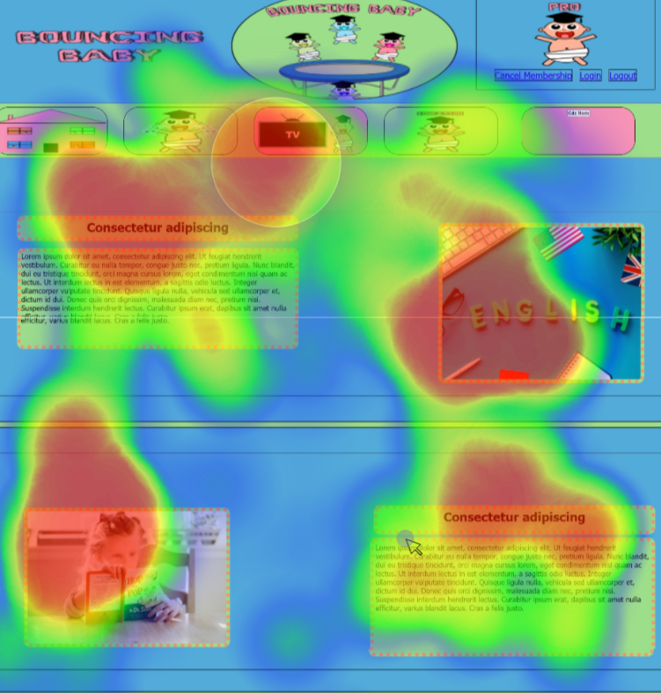

(AO)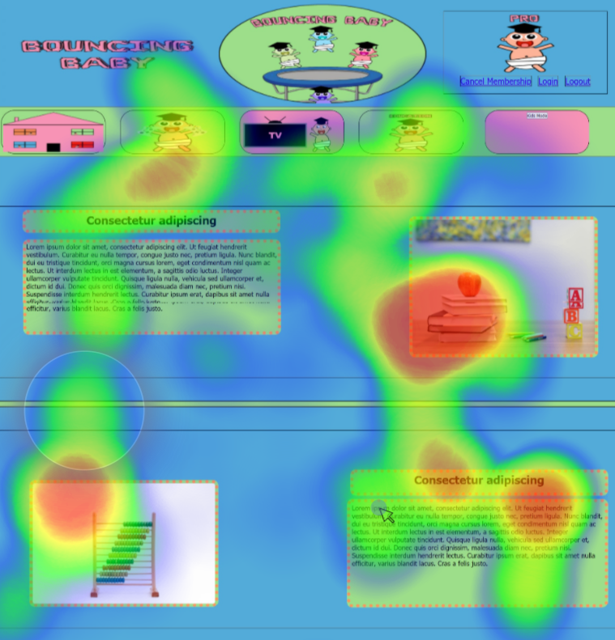

(AP)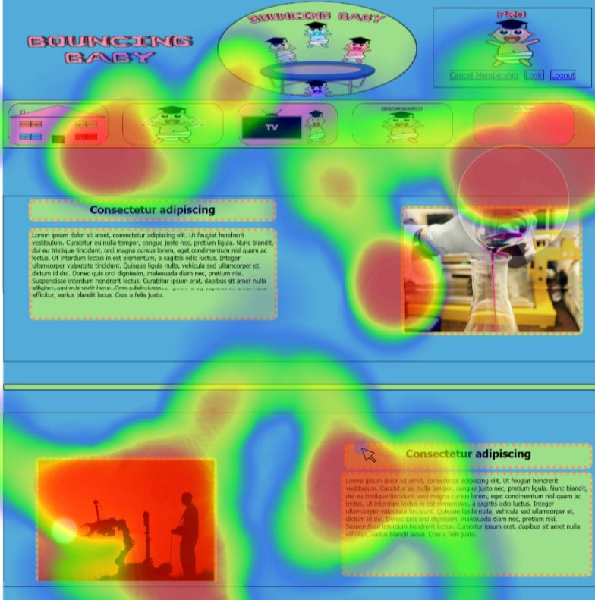

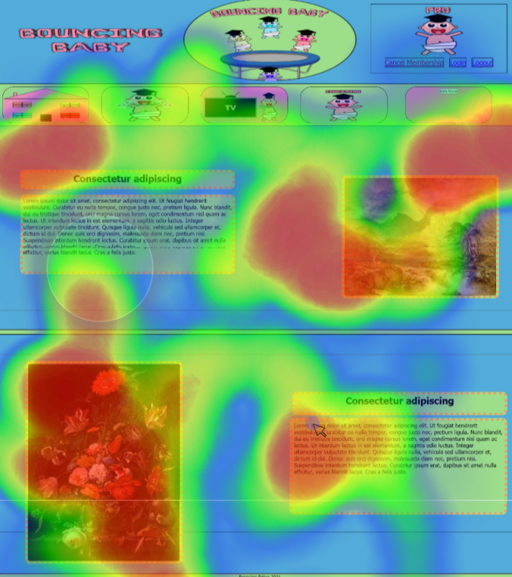(AQ)

(AR)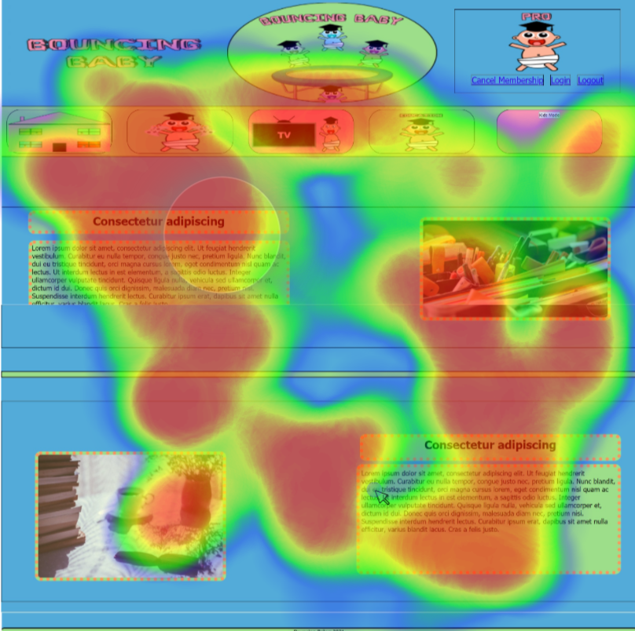

(AS)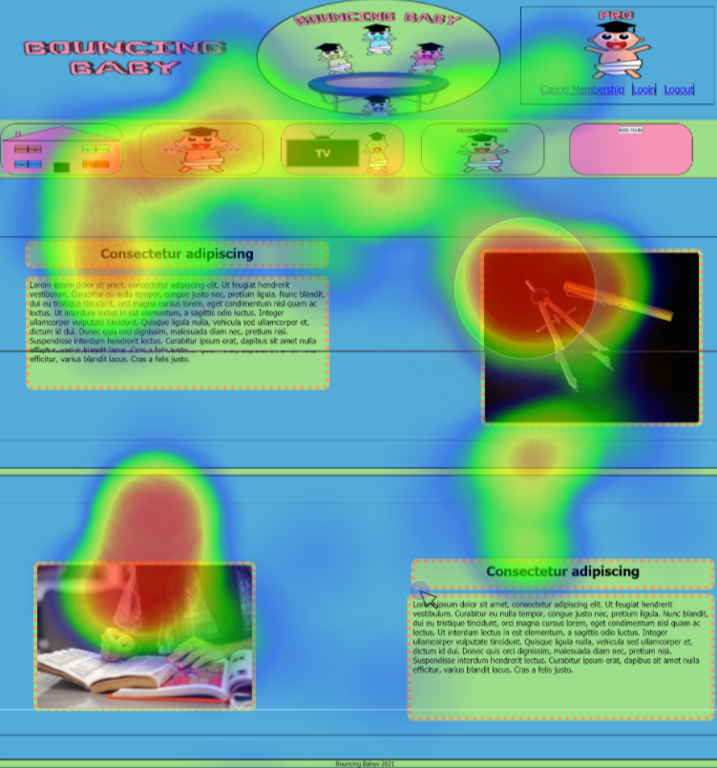

(AT)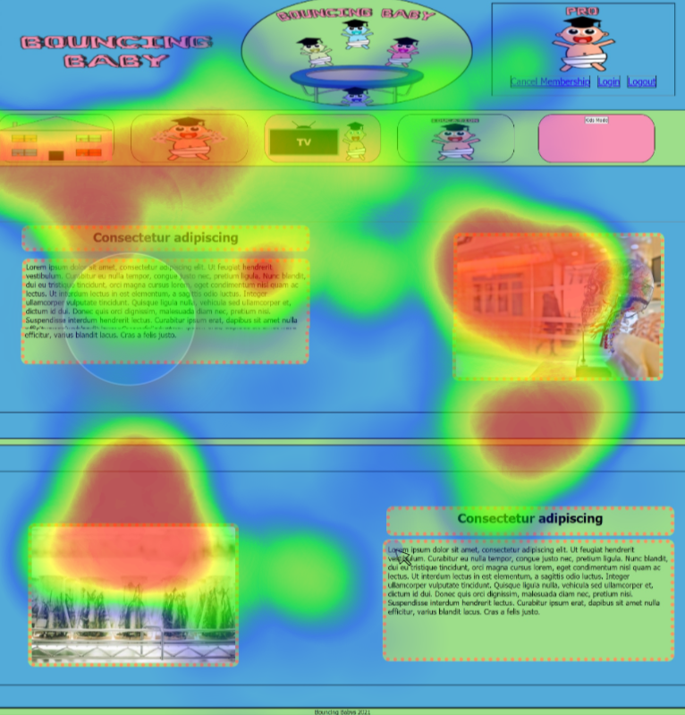

(AU)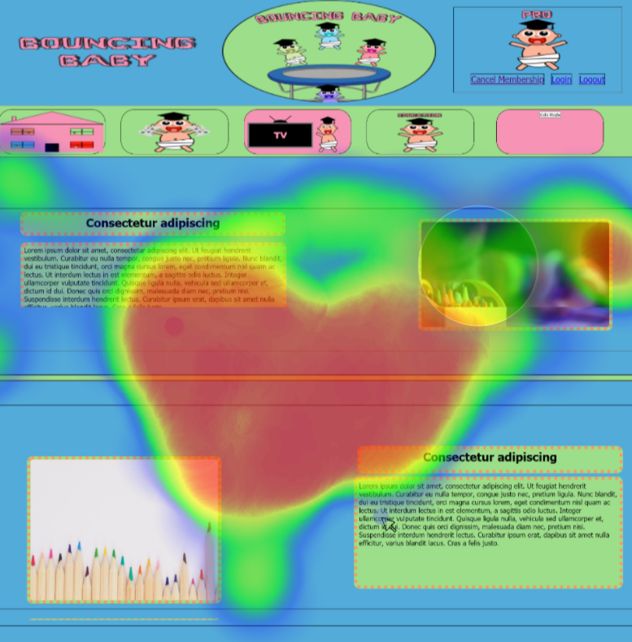

(AV)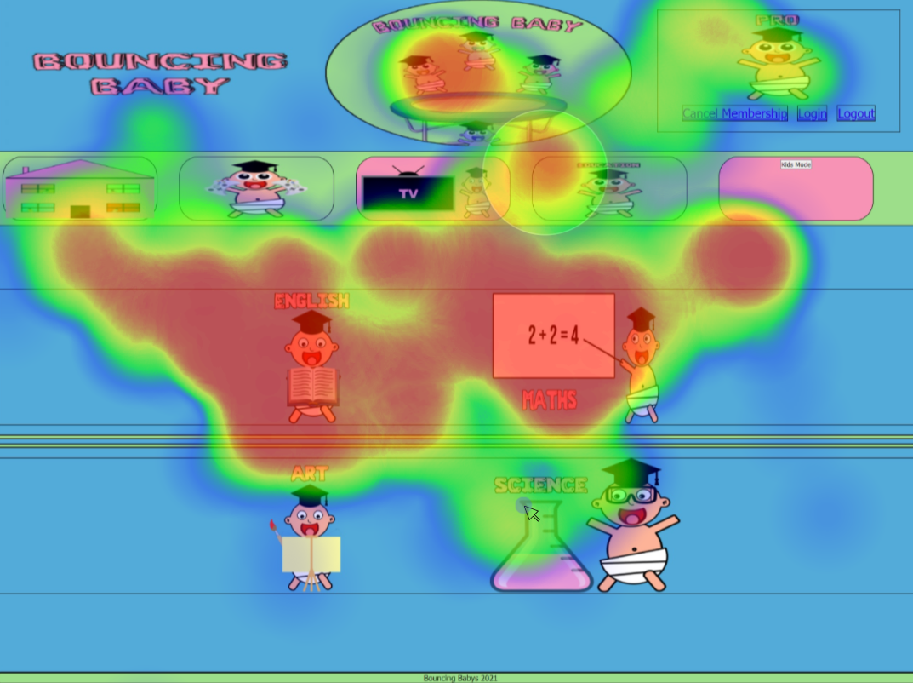

(AW)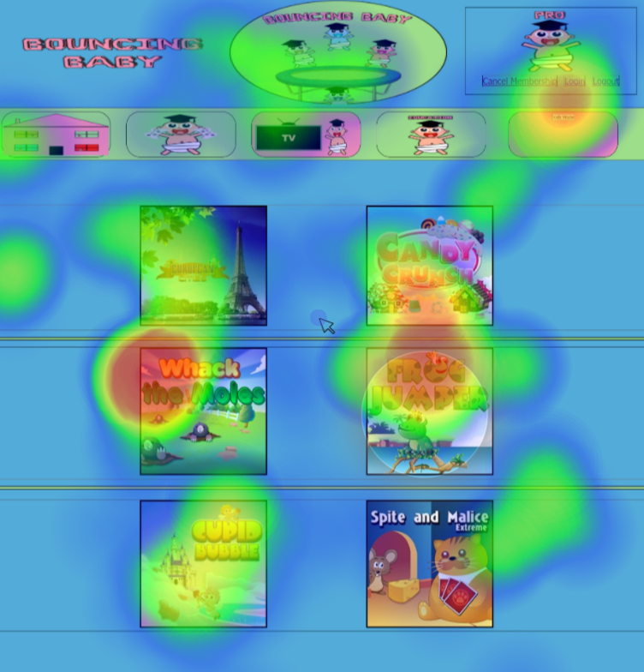

(AX)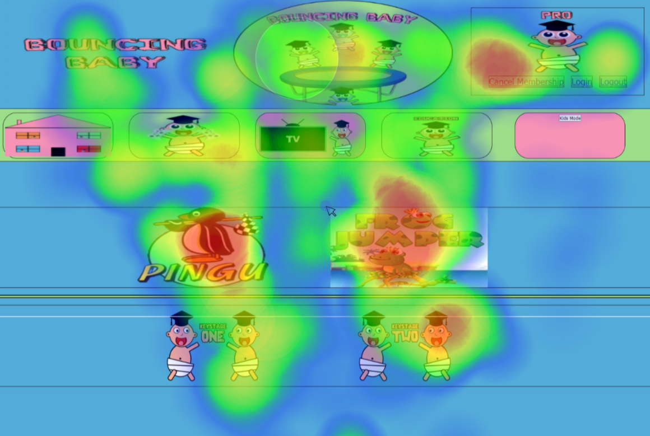

(AY)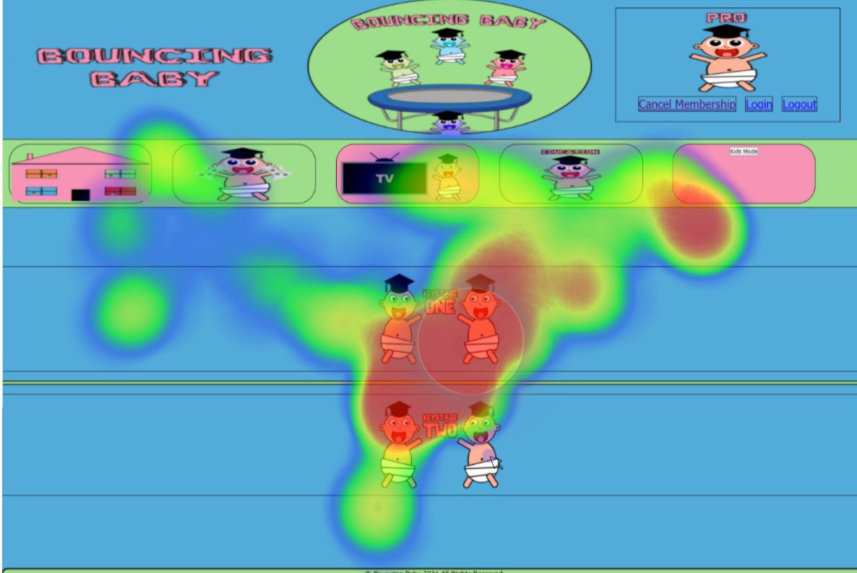(AZ)